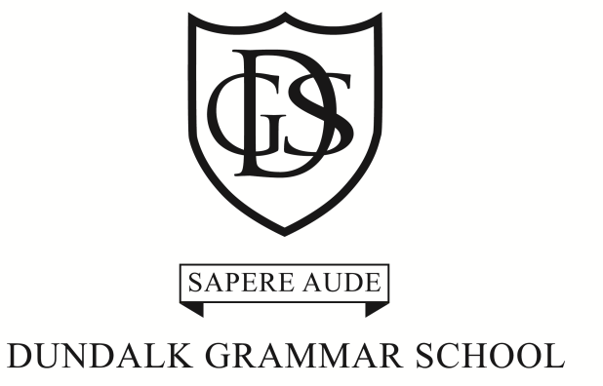

VOLUME 17 Issue 3 NOVEMBER 2017

Each year brings its own joys and sorrows but we trust in the presence of God in our lives that we will be given the strength to cope with whatever difficulties we may encounter.

AFTERNOON TIMETABLE TO DATE:
Monday: Homework prep 3pm-4pm, (5th & 6th classes), Science & Maths Club 4-5pm 4th, 5th & 6th class
Monday: Junior Hockey Training 3-4pm Senior Infants to 3rd class.
Tuesday: Homework prep 3-4pm, Eco Green club 3-4pm for 2nd to 6th class.
Wednesday: Art/Craft Club 2.30pm – 3.30pm, 1st to 6th class.
Thursday: Senior class Hockey Training 3pm-4pm, 4th - 6th classes. (Shin guards and gum shield essential), Chess club 3-4pm for 2nd to 6th class.

DATES FOR YOUR DIARY
Friday 8th December2017: Junior School Musical “Oliver”,2pm in Finnamore Hall & PTA Christmas Fete after the drama production in the Junior School
Tuesday 21st December 2017: Carol Service and Junior School Nativity at 7.00pm
Wednesday 22nd December 2017 returning on Monday 8th January 2018: Christmas Holidays
Saturday 3rd February: Assessment Tests for 6th class for 1st year in Senior School at 9.30am
Friday 9th February 2018 returning Monday 19th February 2018: Mid-term
Thursday 8th March: Scholarship Exam for 6th class at 9.30am in senior school
Monday 19th March 2018: St Patricks Day Holiday
Wednesday 21st March: Ceremony of Penance for First Holy Communion RC in St Patricks at 7.30pm
Friday 23rd March 2018 at 12.30pm returning Monday 9th April 2018: Easter Holidays
Wednesday 2nd May 2018: Sports Day,
Saturday 26th May: RC First Holy Communion in St Patrick’s Cathedral, Roden Place, at 11am
More dates available on calendar hand-out which was sent home and on inside of pupils journal.

PTA
The Christmas Fête is on Friday 8th December 2017. This promises to be a lovely afternoon. After enjoying the children’s performance of Charles Dickens story “Oliver” you are invited to enjoy the festive treats that will be on offer. Tea, Coffee and Punch will be available along with tasty mince pies! Reindeer food will be available to purchase at a nominal cost.
Bake Sale & Competition:
Children can enter their home made cakes into the cake decorating competition. The prize for this competition has been kindly donated by Bernie from Taste Buddies. The winner will receive a voucher which will entitle him/her and 5 friends to a cookery session in Taste Buddies. There will also be a prize per class.Baked goods will be for sale!
Uniform Sale:
A stand will also be set up, selling uniform items. If you have any items which are in good condition that your child may have grown out of, could you please hand them into the school. Uniform items will be priced at €5.
Tote Bags:
Tote bags that feature the portraits of all the children in the Junior School will be available to purchase. You can order tote bags in advance so they will be ready for collection.
Raffle:
We are raffling some fabulous prizes that have been kindly donated to us. Top prizes are a beautiful handmade dolls house and a remote control helicopter donated by the Roma Restaurant. Other prizes are vouchers for McKenna Man, Jade Garden and a rug from Bargain House to name but a few. Books of tickets will be sent home with your child. We appreciate this is a costly time of year for families and so do not feel obliged to purchase all. We would ask that you return any unsold tickets to the school. If anyone however, would like to buy more than one book please ask for more! Any monies raised through the sale of tickets, tote bags and other items on the day will go towards equipment for the children in the Junior School.
PRIZE DAY
Prize day took place on Friday 10th November 2017 at 2pm in Finnamore Hall. Our guest of honour was Ian Moore, School Chaplain.
SCHOOL DRAMA/MUSICAL
The Junior School are preparing for our Christmas Production of the musical “Oliver”. It will take place on Friday 8th December 2017 in Finnamore Hall at 2pm.
MS READATHON
Congratulations to all who participated in the MS Readathon. €1204 was raised. The ‘thank you’ gifts will be available in 2018.
CHRISTMAS SHOEBOX APPEAL
The children collected shoeboxes with little gifts for children in the Third World. Team Hope was delighted to come to school and chat to the children and to collect over 105 boxes. This year’s shoeboxes will go to Ukraine and Belarus
UNIFORM
As the weather gets colder, children are wearing their coats into school. Please make sure all items of clothing are clearly labelled. DGS beanie hats are available in the school uniform shop Michael Lynch in Dundalk.
SPORT
Congratulations to Marlene Ofterdinger who plays with the 1st year girls hockey team. Recently, they travelled to Cavan for the 2nd league match. The team finished on 0-0 draw but it was a tough match especially playing on gravel. The team is confident for the next league match.
In rugby, Thomas and Liam McNamara travelled a short distance to Dundalk Rugby Club, mill Road for a friendly match against Drogheda Grammar. After a strong start from Drogheda scoring two tries, DGS bounced back with a try from Liam McNamara. Robert kicked down the line,Liam caught the ball and raced down the right wing. Thomas Murray followed suit with another try for DGS. Drogheda fought back with three more tries and DGS finished in a flurry with a try from Turlough. Good game and a score of 25-15 to Drogheda.
TENNIS COURT CLEANING
The tennis courts are being cleaned this week. A few car park spaces have been taped off for safety reasons. This should be completed on Friday. We apologise for any inconvenience caused.
DGS CHRISTMAS ENTERPRISE & TRADE FAIR
A group of children from the Junior School will play carols at the Enterprise Day Trade Fair on Thursday 15th December in Finnamore Hall from 3pm to 4.30pm. The children will dress as elves joining in the festive spirit.
CAROL SERVICE
The school Carol Service and Nativity will take place in Finnamore Hall at school on Thursday 21st December at 7.00pm. Please note the earlier time. All family and friends are welcome.
MANDARIN in the Junior School will begin in March with Ms.Jiajang Zhang from the UCD Confucius Institute.
2018
Junior Infants from January 2018 will finish at 2pm. Sixth class will stay in school for an extra hour from Monday 8th January 2018 for Scholarship exam preparation. The specific day is to be advised. Homework Prep will continue per usual. Classes for RC Communion will also begin in January. Dates and times will be advised.

If you have any news items, you would like to include in the next newsletter, please email ms.lait@dgs.ie
And finally … Thank you to all parents who helped out in any way and we look forward to your continued support this year. Elaine Lait

