

Dundalk Grammar School
Staff Handbook

Name___________________________________________

Contents
Staff Handbook

3. Staff timetable numbers
4. SRC 2010-2011
5. Prefects 2010-2011
6. Duty Assistants 2010-2011
7. Code of Behaviour
14. List of School Policies
15. Boys Uniform Code
16. Girls Uniform Code
17. Staff Duties- Early Evening/Prep/ Sunday night in Boarding House
23. Accounts Matters: Financial procedures and purchasing guidelines (August 2010)
24. Supervision Zones
25. School Diagram
26. Study Hall
27. Staff Absences
28. Teacher Examination Guidelines
29. Writing and checking reports
30: Role of Year Head
31. Guidelines for Form Teachers
33. Staff Reminders
34. Form Teachers / Year Heads 2010-2011
35. Form class / Year groups / Assembly timetable
36. Communications Policy
38. School Calendar Aug-Dec 2010
39. School Calendar Jan-Jun 2011
40. School Accident Report Form
42. Sample Bullying record form
43. School Trip consent form
44. Fire Alarm: Instructions to Staff
46. Uniform Communication System
48. Child Protection Guidelines for Post-Primary Schools
50. Dignity in the workplace
56. Students’ Lockers
57. Guidelines for Probationary Teachers
64. Morning, Break and Lunchtime Supervision Timetable 2010-2011
65. Early Evening Duty Roster
66. Prep / Weekend Duty Roster
67. New Students 2010-2011
68. Students Left 2010
69. Class Lists

Staff Timetable Numbers

1 Drury, Cyril
2 Meaqher, Valerie
3 Hoare, Geraldine
4 Hamill, Eithine
5 Ledwith, Stephanie
6 Johnston, Gillian
7 Brady, Paul
8 Matthews, Olwen
9 Kelly, Heidi
10 Brown, Sharon
11 Elvin, William
12 Keeqan, Andrew
13 Byrne, Martina
14 Logan, Loretto
15 Foyle, Francis
16 Conway, Maureen,
17 Norton, Alan
18 Corbett, Brendan
19 Christmas, Helen
20 Gregg, Jonathan
21 Moore, Ian
22 McGuire, Karen
23 Verdes, Leona Elise
24 Herve, Valerie
25 Gray, Jacqui
26 Byrne, Aisling
27 McDonagh, Mairead
28 Hynes, Declan
29 Babington, Sarah
30 McGuire, Aisling
31 Ruddle, Therese
32 Nic Enri, Tina
33 Hunter, Derek
34 O’Reilly, Odharlait
35 Nowell, Scott
36 McKeague, Rory
37 Moffitt, Pearl
38 Clarke, Kate
39 McKinney, Aidan
40 Eveson, Ruth
41 Curling, Hannah
42 Cullen, David
43 Symmons, David
44 Hodson, Emma
45 O'Connor-Moneley, Pamela
46 Cox, Roisin
47 Murphy, Paul
48 Moore, Joyce
49 Clements, Nichole

SRC 2010-2011

Prefects 2010-2011

Duty Assistants 2010-2011

Code of Behaviour
(Revision: June 2009)
No school can function without discipline, but young people cannot develop unless given a degree of freedom appropriate to their level of maturity. We strive to maintain a good balance between freedom and restraint, and we provide a secure framework of a clearly delineated and well-defined Code of Behaviour within which the school rules are deployed. This disciplinary ethos is based on co-operation between students and teachers. Acceptance to the school of a pupil and their attendance shall imply acceptance of and respect for the Code of Behaviour and the school rules in their entirety.
Lapses in this co-operation can resuIt in breaches of school discipline, The most serious of these - vandalism, theft, substance abuse, malicious injury, violent behaviour, inappropriate sexual behaviour, repeatedly defying or swearing at a teacher, repeated or serious bullying - will not be tolerated. Any student found to be in breach of the rules may be expelled depending on the seriousness and frequency of the misdemeanour. In the rare event of a very serious breach of the rules, the Board of Governors, as the ultimate authority, reserves the right to ask any student to leave.
The Code of Behaviour is designed so that all students will have care, concern and respect for the safety and well-being of all persons living in, attending and working in the school. High standards of self-respect and respect for others are expected. This will be shown through high personal standards of honesty, courtesy and consideration for others at all times, co-operation, punctuality, good dress/presentation and hygiene.
GENERAL
l. It is the responsibility of every student to know and to obey the rules of the school. School rules apply on school premises, on the way to and from school, on school-sponsored trips and sports activities in this country and abroad, and on any occasion when the student is in school uniform or otherwise associated with the school.
2. The behaviour of all students at the end of the academic year is expected to correspond to the standard required at any other time of year. End-of-year misbehaviour is not tolerated, and sanctions for such misbehaviour may include expulsion. If appropriate, a school reference may be withheld.
3. All school rules apply to State Examination candidates while the examinations are in progress.
4. School trips, holidays, excursions and extra-curricular activities are organised from time to time to a wide variety of destinations. The staff who supervise these trips and activities do so voluntarily and in the interests of the students. It is, therefore, very important that they are not put under stress in such circumstances. Students are expected to behave in an exemplary manner while on trips and when participating in activities. All school rules with regard to alcohol, smoking, drug abuse, vandalism, general behaviour and courtesy apply fully. Staff are authorised to make special arrangements to send misbehaving students home, at the expense of their parents. This may involve rearranged flights if the trip is abroad.
If a student misbehaves while on a trip or activity, a record of such misbehaviour will be kept by the school and the incident(s) reviewed by the Year Head(s). Normal sanctions will be applied, up to and including suspension and expulsion in serious cases. Trips and activities are a privilege, not a right. If necessary, the school may refuse permission to participate if a student disrupts normal class, has misbehaved on a previous trip or generally has a poor disciplinary record. In this instance, parents will be informed by letter, a copy of which will be retained in the student’s file.
5. The school reserves the right to discipline students for any unforeseen unacceptable behaviour.
UNIFORM
6. Correct uniform, as defined in the school’s Uniform Code, must be worn travelling to and from school, during the school day, during state examinations and for sports. School uniform is also required on school trips, matches and other events at which the school is represented, unless students are informed otherwise.
7. Students are expected to comply with the school’s Uniform Code. It is the student’s responsibility to ensure that uniform is always correct and clean, in good repair and worn neatly. Students are expected to have recourse to spare items of uniform in the event of clothing or footwear being soiled or lost. Non-uniform items of clothing are not permitted and may be confiscated. A student will be given a verbal warning for the first entry in the School Uniform Folder, after a second entry a letter will be sent to parents; a third entry will merit a one hour Friday detention, and parents will be informed. The school reserves the right to remove from class any student whose dress/appearance does not conform to the Uniform Code.
SCHOOL HOURS/PUNCTUALITY
8. School hours are from 8.50 each morning until 3.50 in the afternoon, except for Wednesday when class finishes at 2.40 to facilitate games and other extra-curricular activities. Students should be in school no later than 8.45 so that books can be organised before Assembly or Form Class, which starts at 8.55. Day students must leave the school premises after class (3.50pm, except 2.40pm on Wednesdays) unless they are directly involved in after school activities under the supervision of a member of staff. Students are asked to return home directly without delaying in the local shopping centres.
9. Punctuality is essential for Morning Assembly (8.50am), for all classes and for all school events.
l0. All students must attend Morning Assembly or Form Class (bell at 8.50am). Assembly combines a short act of worship with daily announcements. Silence and good order are expected.
11. The morning roll is taken at Assembly/Form Class. It is every student’s responsibility to see that s(he) is marked present each day. If late, students should register "late" at Assembly/Form Class before 9.05, and at the school office if later than 9.05.
12. Students should not be absent on holidays during term time of the standardised school year. Where a student is absent for twenty days or more in any school year the school is required to inform the National Education and Welfare Board (NEWB).
13. As far as possible, appointments (medical, dental, etc.) should be made for out-of-school hours. When an appointment is unavoidable in class time, the school should be informed in writing in advance. For other absences, a note from a parent or guardian, giving a reason for absence, must be handed in to the school office on the day the student returns. It is most important that students are not absent from school during exam weeks. Arrangements will not normally be made to permit students to sit papers outside the standard examination timetable.
14. When students are on the school premises, the Headmaster and staff assume a legal duty of care. No student may leave the school premises during the day, including break and lunchtime, without the express permission of the Headmaster, Deputy Principal or Head of Boarding. Having received permission, the student must sign out in the book kept in the school office for this purpose and sign in on return. A note from parents does not in itself permit a student to leave the school grounds. If a student leaves the school premises without permission, the school is then unable to discharge its duty of care, and can accept no liability in case of accident or injury. Any breach of this regulation may result in suspension.
HEALTH AND SAFETY
15. Students must not run in the school buildings or between them. They must not congregate in traffic areas, e.g. the Bell Corridor or the hallway in the New Building. Queues must be single line with no jostling or queue-jumping.
16. Outdoor and indoor traffic areas must be kept clear of bags and personal items.
17. The neatness and cleanliness of classrooms and other school buildings are the responsibility of the student body. Litter bins are provided in classrooms and around the school and should be used. If students are asked to pick up litter they must co-operate, whether or not they dropped it. Tippex, chewing gum and permanent markers are forbidden on the campus. A sanction of one hour’s detention will apply for chewing gum.
18. Students will be made aware of particular codes of discipline in all areas, particularly in specialist rooms such as the laboratories, the library, Home Economics room, Woodwork room or Art room. Compliance with these codes is essential for good order and safety.
19. The Headmaster and/or Head of Boarding must be notified in all cases where a student is taking prescribed drugs at school.
20. Students are not permitted to park cars or motor cycles on the school grounds without permission from the Headmaster. Anyone who seeks permission must supply the car’s registration number and evidence of current insurance. Where permission has been granted, the vehicle concerned must be parked in the area designated by the Headmaster and display the official school parking permit. Spaces are subject to availability. Students may not offer transport to other students to or from school or to school-related events without the explicit written permission of all parents concerned, copies of which should be lodged with the Headmaster at least 48 hours in advance. Cyclists are strongly encouraged to wear helmets, to use reflective bands and to lock bicycles in the appropriate places provided for their storage.
21. Smoking by students and the possession of tobacco, lighters, etc., whether in school or travelling to or from school, or on any trip or school-related activity in this country or abroad will lead to two days’ suspension for a first offence. Subsequent offences will incur an extra day’s suspension each time. After a third offence the case will be referred to the Board of Governors. Expulsion will be considered for repeat offenders. (See Policy on Substance Use).
22. The possession or consumption of alcohol in school, in school uniform or on school related activities in this country and abroad is strictly forbidden, regardless of the student’s age. Nor may any student enter licensed premises, buy or consume alcohol whilst in school uniform or otherwise clearly identified as a student of the school. Any breach of this rule will be considered a serious disciplinary matter and will automatically incur a minimum of three days’ suspension. Repeat offending will be considered as worthy of expulsion. (See Policy on Substance Use).
23. The school sees the abuse of narcotics as an extremely damaging personal choice which its students must not make. This type of abuse is all the more dangerous as the abuser usually encourages others. It is made clear to students that the school cannot permit drug offences and that anyone who presents a threat to the school, by introducing drugs in any form whatsoever, can expect to be expelled. The school draws no distinction between hard and soft drugs.
In the case of any student found using illegal drugs, in possession of them, supplying them to another pupil or under the influence of them while in school, the school reserves the right to involve the Garda Siochana and the parents of the student, offering advice to the parents on where to obtain expert professional help. (See Policy on Substance Use).
24. No student may have in his or her possession at any time a firearm, fireworks, knife or blade of any size, laser or other offensive weapon of any sort. Students are expected to behave at all times in a manner which will not put others at risk.
25. The school community believes that each student has the right to an education free from fear and intimidation. Bullying is not tolerated. A confidential disclosure policy is encouraged for any student who feels exposed to any type of bullying behaviour. This applies equally to any other student being subjected to, or who witnesses any other student being subjected to, behaviour such as name-calling, threats, humiliation, intimidation, physical violence or social exclusion. The student is advised to inform his/her form teacher or any member of staff or to place a confidential complaint / report in the box outside the Headmaster’s office door. Enquiries will be made in a manner that respects the confidentiality of the initial complainant.
Parents should feel free to approach the school at any time if they feel concerned about bullying issues. A school anti-bullying policy is in operation.
STUDENT RESPONSIBILITIES
26. Basic good practice in the classroom will include punctual arrival; having correct texts, copies and equipment; properly completed homework; a general willingness to participate without answering out of turn; prompt completion of classwork; and overall respect for the classroom processes of teaching and learning. Within and outside class, students are expected to comply promptly with the instructions and decisions of their teachers. A bottle of water is permitted in the classroom, but otherwise no food or drink.
27. It is school policy that homework will be set on each of five school days. Work must be accurately recorded in the student’s journal and must be ready for the set date. Boarding students must prepare their work during evening study (two hours for lst year, up to three hours for 2nd - 6th years); day pupils are likewise expected to allocate sufficient time for thorough preparation of homework. Students must ensure that they keep a clean journal. They should have the journal with them in all classes as teaching staff may wish to inspect it.
28. Laptops may be used with the permission of the teacher in charge of class, study hall or prep on the basis that the student’s laptop screen is readily visible to the teacher. Students are reminded of the conditions of the school’s Acceptable Use Policy (AUP) for Computer and Internet Usage.
29. Students must have their clothes, appropriate books and equipment clearly identified, and are expected to be responsible at all times for the maintenance and safe—keeping of these and other personal possessions. Students should not leave money or valuables, e.g. laptops, unattended at any time. The school will not accept responsibility for any loss or damage incurred. (Parents are advised to check the extent /conditions of cover on their home contents insurance policy.)
The school operates a lost property office.
30. A book locker is assigned to each student, who may go to this locker before Assembly (before 8.50 a.m.), at break, during lunch-break and after school. The school is not responsible for students’ books or other property stored on the premises. A sports locker is also available if required. All lockers must be emptied at the end of each term. Lockers remain the property of the school and must not be used for any purpose contrary to school rules. Lockers may be searched randomly or as required by appropriate school staff with the authority of the Headmaster. This may be in the presence of the relevant student or not, at the Headmaster’s discretion. Searching of lockers must be sanctioned by the Headmaster, Deputy Principal or Head of Boarding and carried out in the presence of not less than two members of staff.
31. Honesty is expected at all times, and students are expected to prepare their homework and sit all examinations without copying or cheating. Students are advised to seek clear instructions from teachers where group or team work is scheduled to ensure their position is not compromised, especially with regard to project work for state examinations.
32. Mobile phones and personal music/entertainment equipment may be used only at morning break and at lunchtime. At all other times they must be switched off and kept out of sight during the school day. The taking and transmission of photographs by mobiles is not allowed while on the school premises or at school related activities elsewhere, nor is the possession or circulation of any inappropriate images. Phones/music equipment used inappropriately will be confiscated and held for a minimum of one day for a first offence. Different sanctions may apply in the boarding house.
33. Students may not arrange for the delivery of any goods to the school.
34. Students are personally responsible for all damage they may do to property whether accidental or otherwise. Parents are liable for costs incurred, and will be billed as appropriate.
35. Students’ friends from outside the school (i.e. not enrolled in DGS) may not enter school grounds or premises except to attend events for which invitations have been issued. While the Code of Behaviour applies in the context of school activity as a whole, for practical purposes the operation of the disciplinary process associated with this Code of Behaviour makes the distinction between classroom discipline and general school discipline.
Classroom Discipline
Generally the subject teacher will deal with work / behavioural problems such as:
- homework not done
- poor effort in class
- arriving late to class
- lack of correct books / equipment
- talking in class / other disruption
- bad language / inappropriate comments
- rudeness
- graffiti / vandalism
- use of mobile phones or any electronic equipment
- uniform/ make-up/ accessories
The usual sanction for less serious problems will be a reprimand and a warning from the subject teacher who may also write in the student’s journal. This note must be countersigned by a parent.
Repeated or more serious problems will lead to an entry under the student’s name in his / her form class book. The subject teacher may also telephone or send a letter to the parents detailing unsatisfactory effort or behaviour.
If there is no improvement, the subject teacher will consult the Form Teacher who will discuss the issue with the student, issue a further reprimand or warning, contact the parents, inform the Year Head, and the Guidance Counsellor where appropriate.
If problems persist, the Year Head will meet the student and may, as appropriate:
- issue a report card
- set detention (Friday 4-5p.m; parents are informed by letter)
- seek a meeting with parents
- recommend suspension or other sanction
The Year Head will keep other pastoral care personnel informed.
Minor Misdemeanours outside the Classroom
In general the staff members present will deal with disciplinary problems, for example at break, lunchtime, school trips and events. The first sanction for minor misdemeanours will be a reprimand and a warning from the teacher dealing with the matter. If deemed necessary the incident will be reported to the appropriate form teacher(s) and entered in the student’s Form class book.
Serious Breaches of School Discipline
Major incidents such as:
- serious disruption of class
- abusive behaviour to staff or other pupils
- violent behaviour
- not attending classes
- leaving school premises without permission
- bullying of staff or pupils
- abuse / destruction of property
- theft
- smoking, drinking or substance abuse will be dealt with by the Year Head(s) and / or Deputy Principal / Headmaster and outside agencies where appropriate.
The procedure for dealing with serious breaches of school discipline will be as follows:
- students concerned will be interviewed, where possible by two teachers. Where appropriate, reports will be sought from all relevant parties.
- if appropriate, the Headmaster may decide to suspend a student. Parents will be informed of this decision in writing. If the suspension is to be immediate, parents will be informed by telephone, but the reasons for suspension will be notified by letter as soon as practical. In the case of a suspension of more than six days, or where the student has been suspended for more than twenty days in the school year to date, the Education Welfare Board must also be informed.

- parents have the right to appeal a suspension, and, in the case of a successful appeal, the suspension will be removed from the student’s record in the school.

- in more serious cases, the Headmaster may recommend expulsion to the Board of Governors. Parents will be informed of this and will be provided with a full written description of the allegations against the student and the case being made to the Board. They will then be invited to make a written submission to an emergency meeting of the Board.

- parents, and the student if aged eighteen and over, will be invited to attend the meeting and will be present when the Headmaster outlines the case against the student. The parents will have an opportunity to respond, after which the student, parents and the Headmaster will withdraw from the meeting. The Board will consider the evidence presented and will make a decision at the earliest possible opportunity. This decision will be communicated formally to the parents by the Secretary of the Board. Where a decision to expel has been made, the Education Welfare Officer will be informed under Section 24 of the Education Welfare Act (2000). Parents will also be informed of their right to appeal under Section 29 of the National Education Welfare Act.

SCHOOL PLAN
Table of Contents
1 Statement of the School’s Mission and Aims………………………………………………..……..1
2 Brief Profile of the School: its History and Socio-cultural Context………………………..……....2
3 Brief Outline of School Resource ………………………………………………………………...….3
4 Management Structure ………………………………………………………………………..…….4
5 Admissions Policy ……………………………………………………………………………..…….5
6 Ethos .....………………………………………………………………………………………..…….6
7 Curriculum: Provision and Policies ……………………………….…………………………...…….7
8 Extra-Curricular Activities ……………………………………………………….…………...…..….8
9 Code of Behaviour ...……………………………………………………………………….…..…….9
10 Uniform/Dress code ……………………………………………………………….…..………….10
11 Anti-Bullying Policy …………………………………………………………….….…….……….11
12 Policy on Substance Abuse ...………………………………………………………….…….…….12
13 Pastoral Care - School Statement ..………………………….………………………………….….13
14 Guidance and Counselling Policy ...……………………………………………………………….14
15 Homework Policy ..………………………………………………….…………………………….15
16 Relationships and Sexuality Education ………………………………………….…………….….16
17 Acceptable Use Policy (AUP) …………………………………………………….……………….17
18 Email, Internet and Telephone Usage …………………………………………….……………….18
19 Communication Procedures ..…………………………………………….…….………………….19
20 Dignity at Work Charter and anti-Bullying Policy ……………………………….……………….20
21 Special Educational Needs Policy …………………………………………….……………..…….21
22 Critical Incident Management Plan ...…………………………………….…………………….….22
23 Guidelines for Probationary Teachers .....………………………………………………………….23
24 Safety, Health and Welfare at Work ...…………………………………………………………….24
25 Data Protection Policy (in preparation) ..………………………………………………………….25

UNIFORM / DRESS CODE (GIRLS)
DAY UNIFORM (ALL PUPILS)
1. School rain jacket with crest 6. Stockings - navy knee stockings or tights (5
2. School blazer navy (mandatory) pairs) not patterned, not brightly coloured, not
3. School skirt two grey pleated (not mini not 7. Shoes must be black leather, flat heeled shoes,
4. School pullover two navy V- necked with (not high heels, not suede, not canvas, not
school crest (not round necked, no motifs) patent leather, not boots, no buckles or
5. White shirts three - no buttons on collars, short ornaments and not with thick crepe soles.
sleeves acceptable. Collar size should allow Please refer to Website
top button to be closed. Only white may be 8. Scarf - school scarf only, if desired.
worn under shirts. 9. School tie
10. Hat- school woollen hat only, if desired.
SPORTSWEAR (ALL PUPILS)
11. Navy skirt (hockey players only — optional) 17. School track suit with school crest (mandatory
12 School polo Shirt (White, mandatory) only for students taking PE and on school teams)
13 Long Sleeved base layer (Optional) 18. Equipment (if needed) tennis racquet, hockey
14. Navy knee socks (mandatory) stick, shin guards, gum shield. (N.B. safety
15. Sports shoes and astro-turf trainers if doing P.E equipment mandatory for hockey)
or playing hockey. 19. Kitbag (optional)
16. Navy sports shorts (mandatory) 20. Hockey stick bag (optional)

BOARDERS
21. Pyjamas Two pairs 25. Bath towel
22. Slippers 26. Face towel
23. Toilet kit 27. Underwear
24. Shoe polishing kit 28. Duvet (N.B. the school provides sheets/pillows
and pillow cases).

NOTES
• All articles are to be clearly marked with the student’s name.
• All students must have their top shirt buttons closed, ties neatly in place, shirts tucked under waistbands and be otherwise neatly presented at all times. Coloured T-shirts or T-shirts with motifs must not be worn under school uniform.
• Shoes should be polished each morning.
• Hair should not show any excesses deemed inappropriate by the school management, e.g. unnatural colouring or extreme styles. Girls are permitted only brown or black slides; hairbands or ribbons should be black or navy.
• Boys must not wear their hair spiked, crew cut, long at the back, or shaved. The lowest permissible blade cut is no.4. Boys must also be clean shaven.
• No make-up, nail polish or jewellery allowed, with the exception of one stud earring only in each ear for girls. Boys must never wear studs or earrings.
• No headgear is permitted, except for woollen hats with the school crest which may be worn only outdoors in winter.
• Correct sportswear must always be worn for PE/ games.
• The school reserves the right to remove from class any student whose dress/presentation does not conform to the school’s Uniform Code.
• The sole approved school uniform supplier is Michael Lynch. Items sourced elsewhere may not meet the required standard. Supplier: Michael Lynch, 8 Clanbrassil St., Dundalk (042) 9331564 June 2010

UNIFORM / DRESS CODE (BOYS)

DAY UNIFORM (ALL PUPILS)
1. School rain jacket with crest 6. Socks dark grey - 5 pairs.
2. School blazer navy (mandatory) 7. Shoes must be black leather, (not suede or
3. School trousers two pairs of mid-grey trousers. patent leathcr not boots. Or canvas, no
Plain black leather belt with plain buckle buckles or omaments and not with thick
4. School pullover two navy V-necked with crepe soles).
school crest (not round necked, no motifs) Please refer to website
5. White shirts three — no buttons on collars 8. Scarf - school scarf only, if desired (not short
sleeves acceptable. Collar size should club scarves).
allow top button to be closed. Only white 9 School tie
may be worn under shirts. 10. Hat - school woollen hat only, if desired (not club hats)
SPORTSWEAR (ALL PUPILS)
11. Sports shorts plain white (mandatory) 17. Astro-turf trainers
12. Long-sleeved sports shirt Royal Blue with 18. School track suit with school crest
school crest (mandatory) (mandatory only for students taking PE and
on school teams)
13. School polo shirt (optional) 19. Equipment (if needed) tennis racquet,
14. Long sleeved base layer (optional) hockey stick, shin guards, gum shield (N.B.
15. Sports socks Royal Blue (mandatory) all students should have at least 1 gum
16. Football boots (if needed) Shield)
20. Kitbag (Optional)
21. Hockey stick bag (Optional)
BOARDERS
22. Pyjamas Two pairs 26. Bath towel
23. Slippers 27. Face towel
24. Toilet kit 28. Underwear
25. Shoe polishing kit 29. Duvet (N.B. the school provides
sheets/pillows and pillow cases).
NOTES
• All articles are to be clearly marked with the student’s name.
• All students must have their top shirt buttons closed, ties neatly in place, shirts tucked under waistbands and be otherwise neatly presented at all times. Coloured T-shirts or T-shirts with motifs must not be worn under school uniform.
• Shoes should be polished each morning.
• Hair should not show any excesses deemed inappropriate by the school management, e.g. unnatural colouring or extreme styles. Girls are permitted only brown or black slides; hairbands or ribbons should be black or navy.
• Boys must not wear their hair spiked, crew cut, long at the back, or shaved. The lowest permissible blade cut is no.4. Boys must also be clean shaven.
• No make—up, nail polish or jewellery allowed, with the exception of one stud earring only in each ear for girls. Boys must never wear studs or earrings.
• No headgear is permitted, except for woollen hats with the school crest which may be worn only outdoors in winter.
• Correct sportswear must always be worn for PE/ games. -
• The school reserves the right to remove from class any student whose dress/presentation does not conform to the school’s Uniform Code.
• The sole approved school uniform supplier is Michael Lynch. Items sourced elsewhere may not meet the required standard. Supplier: Michael Lynch, 8 Clanbrassil St., Dundalk (042) 9331564 June 2010

Staff Duties -Afternoon, Prep and Sunday Night.
EARLY EVENING DUTY (updated 29/6/10)
2.40/3.50 Roll Call in afternoon
Wed/Fri A full roll of all boarders should be taken at the Duty Point as soon after 2.40/ 3.50 as possible to facilitate students going to games and to minimise opportunities for disorderly behaviour in the corridor. Students should sign in while standing outside the closed half door, which should remain closed at all times. The duty box should always be kept behind the desk at the Duty Point. Using the shorthand notation provided in the roll book, indicate what each student is doing for the afternoon under the column marked A. If a student has permission to go down town and has handed in the appropriately signed slip (signed by either, the Headmaster, Deputy Principal or Head of Boarding) then they can be issued with a pass and a tick should be put in the column marked D. It is the responsibility of all students to check in personally, it is not acceptable for one student to check in another. It should be possible to have the full roll taken in ten minutes and therefore it should not interfere with games.
Notice of permission to leave the school may also be advised on the Boarding Notice board in the staff room.
Any student leaving the campus must have his/her personal School Pass, (apart from prefects, who sign in and out). On returning to school students must report directly to the teacher on dufy, and return the School Pass by 5pm at the latest. This should happen at the Dug Point. Record late returns/failure to return passes in the duty diary.
On completion of the roll the teacher on duty should walk through the school checking that classrooms are locked and that cleaning duties have been completed (i.e. papers picked up and chairs put on top of the desks).
Where possible this should be done before the cleaning staff begin their work.
Other areas to be visited in supervision of students during the afternoon are classrooms, Boarders Common Rooms/TV room and former Junior School rooms, toilets, locker rooms, verandah area, '89 building including concourse area upstairs, prefab area at rear, Tennis Courts and generally around the school grounds. Note excluded areas e. g. lawns.
Students waiting for the train should be at supervised study in N2.
Students should not be allowed to be in classrooms (apart from N2) during the afternoon. Day students should not be on school grounds in the afternoons and should be asked to leave immediately school is over unless they are involved in sports or supervised study. Otherwise, those doing sport at 5pm should leave the school grounds at 3.50 and return for 5pm.
It is important to walk around the campus regularly (throughout the afternoon.
N.B. Check that the Study Hall is locked throughout the afternoon and fully prepared for Prep i.e. free from litter and with all the required desks and chairs in order. It is essential that all this be in readiness for the start of prep and the teacher on evening duty should not have to do this at 6pm.
5.10 The teacher on duty should go to the dining hall. Students should be supervised during tea and while the dining hall is cleaned after tea.
5.50-6.00 Students should prepare books etc. for prep and should be checked by teacher.
6.00-6.15 Please check that the teacher on prep duty has arrived.
Check that students (forms 2-6) have all gone to Study Hall apart from those who had games until 6pm ·they should be in prep by 6.20. Check on students in unsupervised prep and take the roll.
6.15-7.00 Afternoon duty continues with supervision of first form students in R6.
6.55 Supper for first form students with teacher on duty.
7.00-7.15 General supervision of canteen and surrounding area. Please remain in this area througout supper time. It is very important to ensure that students leave back mugs, which should not be taken elsewhere in the school, and that the canteen and corridor around the serving hatch are tidied after supper.
Roll book should be handed over to prep duty teacher.
Afternoon duty ends at 7.15pm.
Procedures in the event of student illness.
A member of staff is on medical cover each evening from 5pm (when the school office closes) until 9.30pm. The teacher on afternoon or prep duty should only need to contact the teacher on medical cover in a critical or emergency situation. Students with minor illnesses should be sent by them to the Duty Point at 7pm or at 9.10pm where the necessary treatment can be provided.
N.B. Students reporting ill should be noted in the Prep diary as should any use of sick bay authorised by the teacher on medical cover.
The Headmaster or Head of Boarding are also on campus or in the locality and contactable by mobile (phone numbers in prep box) in the event of any emergency.
Students should never be allowed to use the photocopying room or to enter the Staffroom which should be locked after 6pm.

PREP DUTY
6.00 Students (forms 2-6) should be in prep rooms with all necessary books and equipment.
Students should be seated according to seating plan at front of prep roll book and should not be allowed to change.
Roll call should be taken at an appropriate time during prep and students should be ticked in on the column marked P.
6th Form Prefects are assigned designated classrooms where they are required to work independently. As such, the teacher on prep duty is not expected to undertake their direct supervision. Any observations on tardiness or lack of application to study should be brought to the attention of the Head of Boarding. All duty staff are encouraged (where possible) to check that these arrangements are operating as they should. Prefects should be reminded that they will be subject to spot checks by staff, including the Head of Boarding (and indeed, as is the case with all boarding students, by the Headmaster).
Students arriving late to prep (e.g. because of music, matches etc.) should report to the teacher before commencing prep. Details of music practice schedule and other regular absences are included in the Prep Box.
Teachers should avoid seeking student absence from prep. Where this is considered necessary permission must be obtained in advance from the Deputy Principal. There are scheduled times available for computer room usage for first and fourth form students and there are two afternoon periods available to all other students. For this reason teachers should not seek permission for students to leave prep for IT related work. Any such absence must be approved by the Deputy Principal.
Under normal circumstances students should not be allowed to move around or out of the prep area to get books etc. as there should be as little disruption as possible of study time.
7.00-7.15 SUPPER BREAK.
7.15-8.00 Prep continues for all forms except for T.Y. students.
Any student who is being disruptive in prep should be dealt with by the teacher on duty and, when deemed necessary, an essay set.
8-8.05 Short break - toilet/ books. Students (including all T.Y. students) should return promptly. Failure to do so should result in a punishment essay.
8.05 Prep continues for forms 2-6. (First form at activities)
9.10 Students may not leave any of the prep rooms until they are cleaned and tidied to the satisfaction of the teacher or prefect in charge. Each student should be responsible for their own desk area and should remain there until given permission to leave.
9.10-9.30 Students may play games on the All-Weather pitch under the supervision of the teacher taking prep. During this time the teacher on Medical Duty will supervise students indoors. As students are informed that they must only be in the designated areas and should not be elsewhere on the campus, it is not expected that the teacher on prep will patrol elsewhere, although any students seen returning from areas (e. g. around the outside of the ’89 building or the Gym) should be challenged Student found away from the designated areas can, at least, expect to be given a detention.
9.30-9.40 Prep duty teacher should oversee students leaving main school. Having ensured that all students apart from the two seniors on lock-up duty have left, the prep duty teacher then goes to the O.L.H..
All significant incidents ge.g. misbehaviour, absence/ late for prep without permission , illnesses etc) should be recorded in the prep diary.
THE PREP BOX SHOULD BE LEFT AT THE DUTY POINT.
Female members of staff should first check in with the teacher on duty on the boys’ side to check that all students have arrived, then proceed to the girls’ side and then once all students are accounted for exit through the girls’ exit door. The teacher on duty on the girl’s side will then lock the main gate to the O.L.H..
Male members of staff should first check in with the teacher on duty on the girls’ side to check that all students have arrived, then proceed to the boys’ side and then once all students are accounted for exit through the boys’ exit door. The teacher on duty on the boys’ side will then lock the main gate to the O.L.H.
9.40 Please note that before leaving at 9.40 it is very important that the teacher on prep checks in with BOTH members on the boarding staff on duty to ensure that all students are accounted for and pass on relevant information, e. g. students returning late from some outing, students who have reported ill earlier in the day, students gone home due to illness etc.
Procedures in the event of student illness
As above- see Afternoon Duty
The Headmaster or Head of Boarding are also on campus or in the locality and contactable by mobile (phone numbers in prep box) in the event of any emergency.

Sunday Night Duty in Boarding House
The teacher on Sunday night duty should get the weekend keys from the Deputy Principal on
Friday afternoon.
8pm Teacher on duty to enter through main gate of O.L.H. (leaving same open), then through side gate (switching the lock to open), and finally enter the building through the Dining Hall door.
8pm -l0pm Teacher on duty stays in Dining Hall and signs in pupils as they arrive. The list of students intending to return will be in the book under the television. Students should return between 8 and 9.l5pm. Parents of students, who having signed the list subsequently decide not to return, must inform the school by ringing the staff duty phone (087 20729l 5) before 9.30. If a student does not turn up and parents have not rung by 9.30 then a list of parent contact numbers is available at the back of the book so that they can be contacted by the teacher on duty. Also a note should be made of students who return to school whose names are not on the list. These students should have a note from their parents explaining their unexpected return.
Students stay in Dining Hall only; they must not under any circumstances be allowed access to the dorms. They should leave all bags etc in the Dining Hall (at the entry side) until they are taken to the Dorrns by the member of staff on night duty at l0pm.
If a student needs to use the toilet they should be allowed to use the disabled toilet on the boys’ side - but should only be allowed to leave Dining Hall one at a time for that purpose.
Students may watch TV or do homework while in the Dining Hall from 8pm - l0pm.
NB It is very important that students are supervised at all times in the Dining Hall.
l0pm Member of staff on night duty arrives to bring students to their dorms and the completed roll and any significant information should be passed on.
Weekend keys should be returned to Deputy Principal on Monday morning.
If unable at short notice to undertake Sunday duty, the teacher should try to organise cover with a colleague or, failing that, contact the Deputy Principal.

Medical Cover 5-9.30pm
The teacher providing emergence medical cover must be present on the school campus at all times between 5 and 9.30pm.
Keys for Sick Bay and for medicine box should be collected from V. Meagher’s post box in staff room and returned to there by 9.30pm. The duty phone should be collected from the Prep Box at the Duty Point (pin no. is 0000). The medicine box and the medical notes diary are kept behind the desk at the Duty Point and should not be taken from there. The medicine box should be locked after each use.
The teacher on afternoon or prep duty should only need to contact the teacher on medical cover in a critical or emergency situation. Students with minor illnesses should be sent by them to the Duty Point at 7pm or 9.10pm.
5.00 Check with Office staff to see if any student has been allowed access to Sick Bay. If so, assess their need to stay there for longer and check if medication has been given. If necessary check on such students again by 6pm. Ensure that the door is locked if room is not in use.
7-7.l5 Be at the Duty Point to administer medicine if deemed necessary to any student presenting with an illness. If in any doubt about appropriate action a call to parents to discuss proposed action should resolve the issue (student can be asked to phone parent on their phone). Access to sick bay can be given if appropriate. A note should be made in the medical diary of all medication administered and of permission to use Sick Bay.
Checks can again be made on Sick Bay if deemed necessary at 8 and 9.10pm however use of Sick Bay for prolonged periods should be the exception rather than the norm. Also students should not be allowed to have visitors (i.e. other students) with them in Sick Bay. If a student is very ill their parents should be contacted and arrangements made for them to go home.
9\.ll0—9.30 Be at the Duty Point during this time. This is for the purpose of providing medical attention where necessary but also to provide a presence in the building to facilitate the Prep Duty Teacher in actively supervising the pupils throughout the school premises.
If medication has been given to a student during the evening then notice of this should be passed to night duty staff (via the prep duty teacher if necessary). Finally check that Sick Bay is left in a tidy condition (if in use during the evening) and, if it needs further attention from cleaning staff, then a note should be left for the attention of the Deputy Principal.
Mobile phone should be left at Duty Point and keys returned to V. Meagher’s post box
As is the case for all members of staff, when on the campus, if any issue (medical or otherwise) arises or is brought to your attention as needing immediate intervention then, where practicably possible, this would be expected.

Accounts matters

Financial Procedures and Purchasing Guidelines (August 2010.)

Pupils
Information correspondence from parents regarding a change in status of Boarding or Day, or leaving school should be passed on to the office and accounts.
It is important that any information regarding a serious change in family circumstances, e. g. redundancy, ill health or loss of a parent is passed on to accounts.
It would be most helpful to both pupils and to Nel to pass on any awareness of need in a particular family.
Excursions
The accounts office will need to be notified of excursions before they take place.
1. To discuss method of payment.
2. To agree on the charge (trip and bus)
3. To be given a list of students taking part, in time for billing.
Payment for trips over €25 should be by cheque, draft or postal order.
Bus booking
Buses are to be booked by e-mail only, to: bookings@anchortoursireland.com, with a "cc" sent to accounts@dgs.ie.
The e·mail should state:
1. Teacher’s name.
2. Date of trip
3. Purpose of trip
4. Destination.
5. Size of bus ordered.
6. Price agreed.
7. List of student’s names for billing to Nel.
School bills
School bills are issued at the end of August (term l), before Christmas (term 2), and before Easter (term 3). Preparation takes at least 2 weeks. Charges to be put on the bill must he approved in advance by the Headmaster and given to Nel as they occur, to be processed immediately (rather than all at the end of term).
Purchases for School
All expenditure on behalf of the School must be approved and signed for in advance by the Headmaster.
Purchases/orders for School of any kind are then only to be made with a Requisition Form, available in the accounts and general offices.
Together with the prompt forwarding of delivery notes and invoices, these procedures are essential to the efficient administration of the School. Goods and Services cannot be paid for without knowing what or whom they apply to, and whether delivery has taken place. Please make a photocopy of the invoice, if required.
Cash expenses are to be kept to a minimum, but when unavoidable, a claim-sheet with receipt attached, should be presented promptly to the accounts office for reimbursement.
Cheque requirement
Please plan ahead, as a signatory is often not immediately available.

SUPERVISION ZONES/DUTIES 2008-2009
Morning Duty (8.45-9.05am)
General supervision of school before and during Assembly, including toilet areas. Please open the Gym doors at 8.45am. At 8.50am (first bell) move around the school grounds and buildings, ensuring that students make their way towards Assembly or Form Class meeting. Late students (after second bell, 8.55am) should also be moved towards Assembly. Ask them to enter the Gym when the talk/prayers are over, and remind them to register late with the prefect on duty. Please report recurring lates/unusual incidents to the Form Teacher, Year Head or DP as appropriate.
Break Duty (11.00-11.15am) & Lunchtime Duty (1.10-1.50pm)

Zone 1
New Building, including 5th/6th year lockers, the immediate surroundings front and rear including car park and back gate, patio, gym, back yard and toilets; help ensure students leave the 5m/6" locker areas before 11.15am or 1.50pm; supervise cleaning.
Zone 2
All-weather (grit) pitch, prefabs and surroundings; lockers - 1st, 2nd, 3rd/4th girls, junior boarder boys; path to front driveway; front garden (out of bounds to students); help ensure students leave the pitch at first bell (l l.l3am or l.45pm); help clear locker areas at ll.l5am and l.50pm, supervise cleaning.
Zone 3
Drive/front gate; Astroturf lawn; front of Old Building, help ensure students leave the Astroturf at first bell (11 .13am or 1.45pm); supervise cleaning.
Zone 4
T and R classrooms; verandah; yard/car park; lockers; old tuck-shop; boarder girls’ lockers; stairs to Computer Room/library; Study Hall; toilets; help ensure locker rooms are cleaned at 11.15am or 1.50pm; supervise cleaning.
Zone 5
Canteen: oversee prefects in queue, serving area and canteen; senior boarder boys’ lockers; help ensure that the canteen is cleared and cleaned and the locker room vacated by 11.15am or 1.50pm.
Cleaning
Please check the cleaning rota (posted in the Staffroom, New Building, Canteen and Verandah) to know which student(s) should report for cleaning duties. Students should be on duty in time to finish cleaning before class recommences - inform the Form Teachers if cleaners do not appear in time for duty.
First Aid
Kit at the Duty Point outside the D.P.’s office. Please inform Audrey O’Brien in the school office in case of emergency. In the event of an accident please complete a School Accident Report Form (copy in Staff Handbook).
School Safety
Your supervision duty is an important contribution towards the orderliness and safety, of school life. If you know you will be absent for your duty period, please arrange substitution with a colleague and inform the D.P. It is also important to be visibly in charge throughout your duty zone for the full duration of the duty period.
This is especially the case while roofing works are in progress.
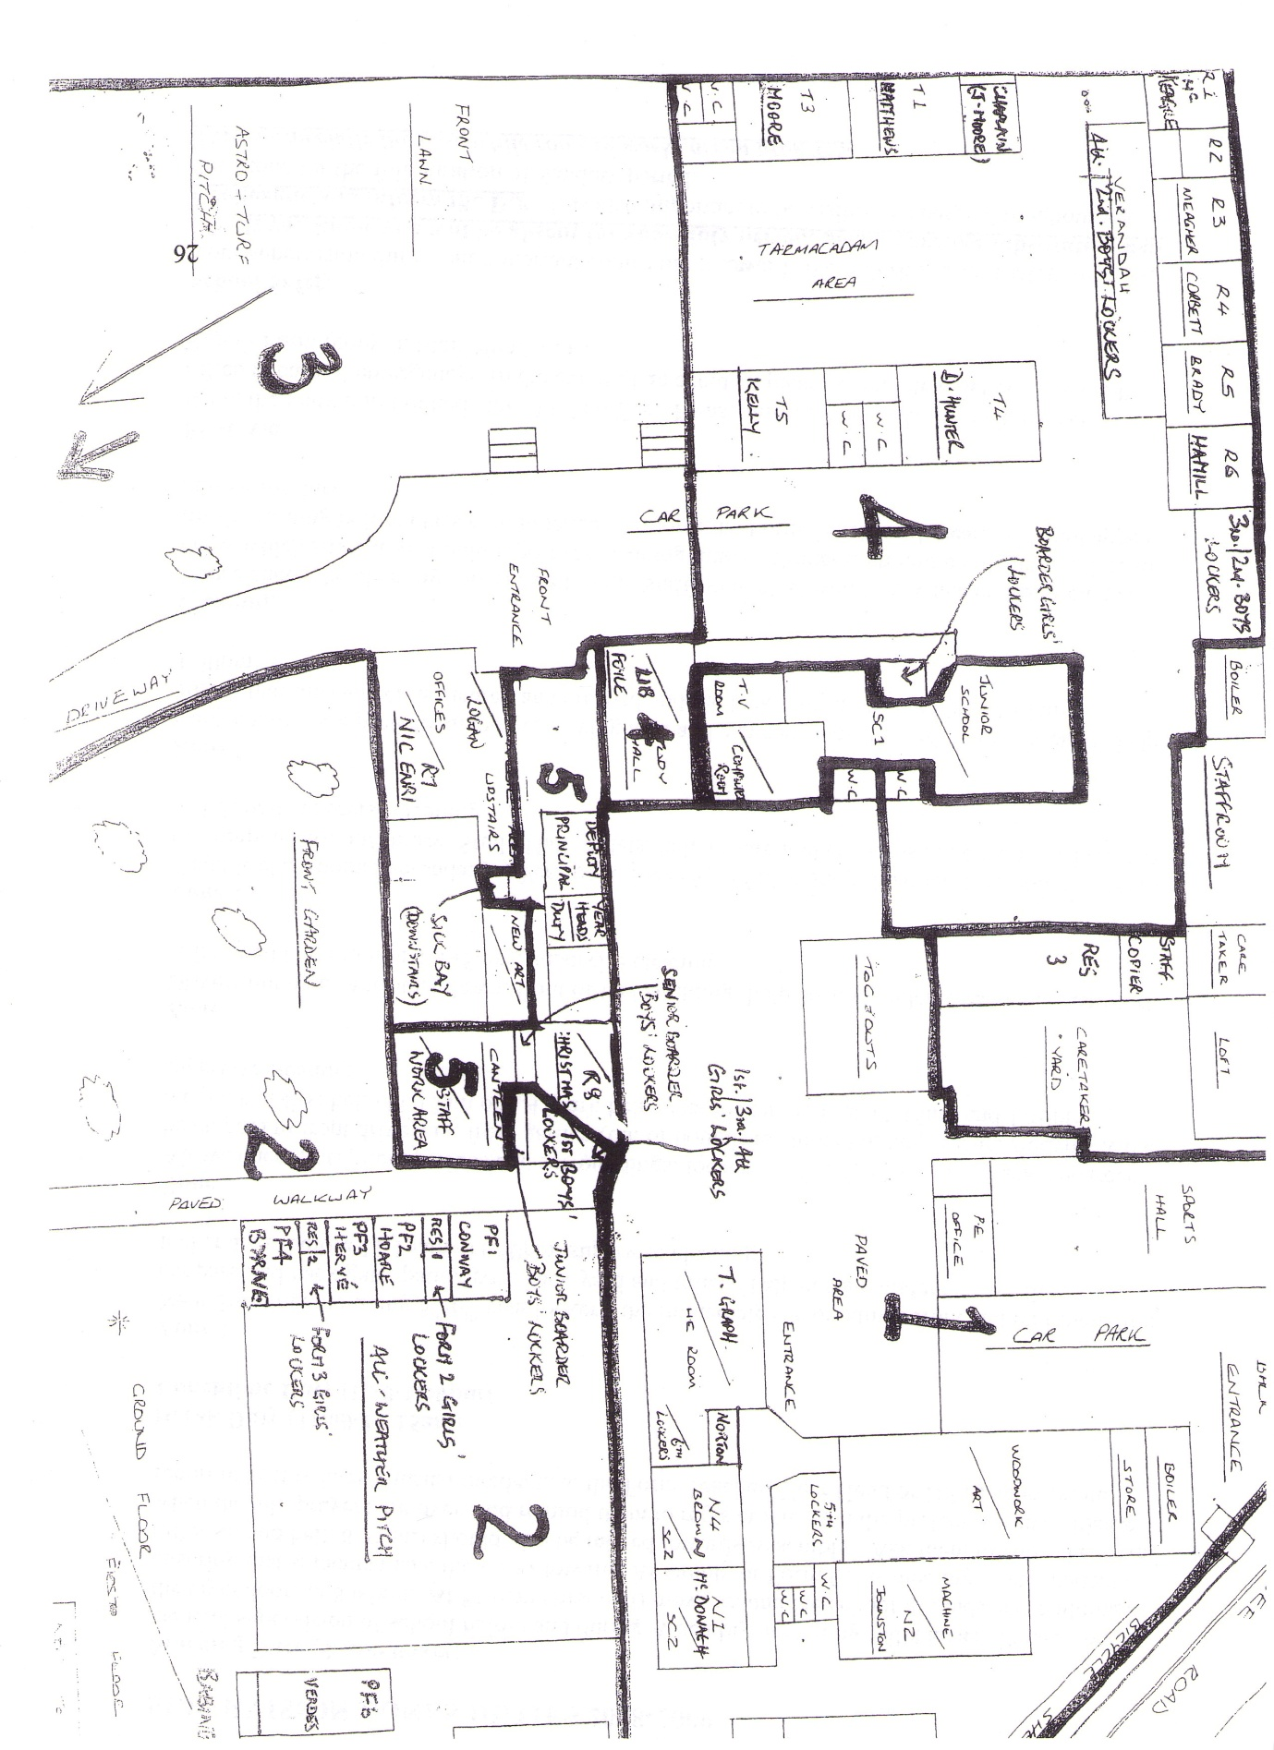

STUDY HALL
The Study Hall can seat 80 students. During the day the Study Hall accommodates those students who do not have a timetabled class at that time - roll lists of these students is compiled early in the school year. Students whose teacher is absent and for whom no substitute is available are also seated in the Study Hall. In the evening, most boarder students do prep there.
At the beginning of each study class, and at the beginning and end of prep, please ensure that the desks are in order and that the room is free of litter. There should be a space between the desks and the wall. Each student should have a separate desk.
If there are relatively few students these are best seated directly in front of the teacher on duty. Allow the back seats to be occupied only when required.
School rules apply as for normal class: no talking, eating/chewing gum, drinking (except water); no music equipment; outdoor clothing must be removed. Late arrivals should be questioned: students may not absent themselves for toilet, etc. any more than at the beginning of any other class. Correction fluids (Tippex, etc.) and permanent ink markers are banned throughout the school.
Check the roll of students timetabled for Study Hall at that time. Compile a list of all students present who are not on your regular list and leave that sheet in the folder provided on the teacher’s desk as this may be needed for later inspection to verify a student’s presence. Record late comers and their times of arrival. Work may need to be distributed on behalf of absent teachers.
Students must be actively involved in study/reading and must remain in place until the bell rings at the end of class, including at break and at lunchtime.
Students may NOT use the Study Hall as a passage area during class hours.
If an excess number is anticipated, a standby teacher will be asked to go to the Study Hall at the beginning of the relevant class period. If there is an excess number and no standby arrives, the teacher in charge should send a student to contact the Deputy Principal.
Efforts will be made to keep the Study Hall in good order during break and lunchtime.

STAFF ABSENCE
Good prior knowledge of staff absence facilitates arrangements for a substitute teacher, or, where this is not possible, for appropriate Study Hall staffing.
PLANNED ABSENCE: Whether for school or personal reasons, write the day(s) and date(s) of planned absence in the diary in the staff room, even if this has already been verbally communicated. Please enter also the reason for absence (e. g. match, in service, personal, etc.) Staff should speak to the headmaster with regard to requests for leave.
If you know that your classes will not be taught by a substitute teacher arrangements should be made to leave work for your classes to do while in Study Hall. Your instructions should be left with the teacher who will be in charge of the relevant Study Hall class period. If a second teacher is in charge of Study Hall students the timetabled teacher will pass on details of work set. You should leave details of work set in the teacher’s pigeonhole and advise him/her that you have done so.
UNPLANNED ABSENCE: If you are unable to give overnight notice of absence, please ring the school office (042-9334459) no later than 8a.m., and ring the office again before 8a.m. on the morning you return. This will facilitate better staff/Study Hall planning for the day. Please do not use any channel for informing the school other than the school office.
If you find you will be late arriving to school, again let the office know as early as you can, with an estimated arrival time if that is possible.
Medical certificates, where relevant, should be handed in to Audrey in the school office.

TEACHER EXAMINATION GUIDELINES
Please ensure that you do the following:
1. When seating students before exams begin, seat them in alphabetical order (unless exceptions are necessary) and in alternate class rows. When seating is complete, draw a seating plan.
2. Read ‘exam regulations’ to students. When supervising an exam, ensure that the exam regulations are upheld.
3. When students are first seated, ensure details of required exam papers are accurately recorded for each room.
4. Check exam supervision list each morning.
5. Bring writing paper and graph paper (if required) to classroom at the beginning of an exam period and return all remaining paper to staff room at the end.
6. At the beginning and end of the exam period, ensure that the room is orderly and tidy.
7. At the beginning of an exam period, check for student absences and ensure students are sitting in their designated places. During the first exam period of the day, complete the absence slip, which will be collected by the secretary.
8. Ensure that desks are clear and bags left at the front or back of the room. Mobile phones must be switched off and in bags. Calculators should be non-programmable.
9. A short (5 min) toilet break may be allowed to senior students before the longer exams begin; during that 5 minutes supervision staff should assume break duty.
10. Ensure that you are aware of the duration of each paper and start each exam so that all papers finish together at the end of the examination period.
11. All exams should be started on time.
12. Ensure that students do not leave their seats during an exam. Bring paper to them when they raise a hand.
13. Toilet breaks are up to the discretion of the supervising teacher and should be recorded.
14. Do not collect exam scripts sooner than five minutes before the end of the exam period.
15. Attempted cheating must be recorded in formbook and reported to the subject teacher and year head.
16. Exam supervisors should not mark their own exam scripts during exams.

Dundalk Grammar School

WRITING AND CHECKING REPORTS
End of term reports are important documents for parents, pupils and for the school. They must be fair to the pupil, neat and complete. Staff are asked to observe the following guidelines. New members of staff should consult with the Year Head if they have any doubts as to the correct procedures.
1. In the cases of new students, check that the report has been properly headed with student name etc. by Form Teacher.
2. Use only dark ink which will photocopy. Check that the carbon copy is easily legible. If necessary obtain a new sheet of carbon paper from the office. The new report books (lst Year, TY and new students in other classes) do not require carbon paper. However, make sure the white card is under the duplicate sheet.
3. It is the responsibility of the subject teacher to check that every pupil is given a report for each subject.
Reports should be checked against class lists.
4. Reports should be kept in class order and must be handled with care so that they remain in good condition. Reports must not be removed from Staff Work Area without permission of Deputy Principal.
5. If a mistake is made which cannot be rectified, inform the Year Head at once. The teacher who made the mistake must arrange that reports are copied onto the new report form.
6. The time and date for completion of reports will be posted in the Staff Room and must be strictly observed. This may be extended only in the case of absence or illness. Remember that sufficient time must be available for the addition of Form Teacher comments as well as proof reading and checking of reports. If there is any difficulty in meeting the deadline you must consult the Year Head.
7. Examination Results
a) The level "H" for Higher "O" for Ordinary or "F" for Foundation must be shown where appropriate.
b) Each subject teacher should calculate a class average showing the average mark obtained by the class in the examination. If the number of pupils is 3 or less, only enter the % mark i.e. give no class average - in such case enter a dash rather than leave a blank space.
c) It is expected that the class average will normally be between the following limits:
lst, 2nd, 3rd Years: 40% - 70% 5th, 6th Years: 35% - 65%.
(Where the class average falls outside this range, the Year Head should be advised).
d) Annual prizes may be awarded on the basis of examination and effort grades. Please be consistent.
e) If an examination has not been completed, place a dash or write "abs" in the % column, If you have marked an examination completed under non-examination conditions, the mark awarded may be mentioned in the comment.
f) If a pupil attempts a subject for which he/she is not a member of a class (with the approval of the teacher of the class) then a mark and comment may be recorded on the report. The mark should not be included when calculating the average.
8. Subject Teacher Comments
a) Comments should not reflect discredit on another teacher or on the school.
b) Comments should not reflect discredit on the Boarding House. Adverse criticisms of boarders’ homework should be made to the Form Teacher, Year Head or Head of Boarding.
c) Comments should not be insulting to pupils or offensive to parents. This does not, of course, exclude remarks re. laziness or carelessness or poor homework.
d) Please use sentences that are grammatically correct. Lengthy remarks, which are often very desirable, should begin in the upper portion of the space provided so that the continuation line reads downwards,
e) Try to balance criticism and encouragement where possible.
f) Extreme changes in a pupil's examination marks from one exam to another (e. g. Christmas, 75%, June 40%) should be explained in the comment,
g) Avoid repeating the Effort Grade in the comment e.g. Effort—6 Comment- Fred has made an excellent effort this term.
h) Check spelling and the pupil’s name on the report heading before writing. Abbreviations are acceptable (e.g. Katie for Katherine) if you are confident that parents refer to the child in this way but avoid nicknames. Version: Tuesday, 25 November 2008
YEAR HEAD
The post holder is delegated special responsibility for promoting the general welfare of all students in the year group and will be assisted by form teachers in this task.
Specifically the duties will include
- Liaise with form teachers, subject teachers and relevant personnel.
- Liaise with pastoral team and external agencies where appropriate.
- Liaise with parents and where appropriate provide information for form teachers.
- Oversee discipline (apply detention, recommend for suspension) and maintain record of same for inclusion on reports.
- Check academic reports and monitor academic progress.
- Monitor and encourage participation in extra-curricular activities.
- Monitor appearance and presentation of students (uniform, hair etc.)
- Monitor and support students who are vulnerable.
- Oversee the induction of students new to the school.
- Ensure that student records are being updated and maintained (Student Files in Office, Form Books in Staff Room).
- Acknowledge achievement.
- Attend parent teacher meeting.
- Monitor attendance.
In carrying out these duties he/she will be responsible to the Headmaster/Deputy Principal who carries ultimate responsibility for these areas.

Guidelines for Form Teachers
Please deal with the following during the first form Class of the Year.
Overall reminder - respect for self, for other students, for all school staff and for school property.
Refer to anti-bullying policy; need for a clean school environment; no litter, Tippex, chewing gum, permanent ink marker, graffiti, minor vandalism; cleanliness in canteen (litter to bins, etc.) clean toilets.
Uniform - (Refer to uniform guidelines / notes and relevant section from Code of Discipline.) Student collars should be wide enough to permit closure of top button. Students should have spare items of uniform if clothing / footwear soiled, damaged or lost. No outer clothing in class; non-uniform clothing will be confiscated.
Punctuality for Assembly / Form class / Class (Refer to Code of Behaviour / brief reminder).
Be in school by 8:45am. Organise books at 8:45, before 11:15 and 1:50 and after class. Return from the pitch / grounds at first bell.
Stand in alphabetical order for morning roll.

Lockers - Only locker holders are permitted in any given locker area except when passing through to a form class.
Students are responsible for their lock, and the condition of their locker.

Absence from school- Refer to Code of Behaviour, especially 12-14. Please emphasise that AWOL may result in suspension. No permission for any student to leave at lunchtime, except for Prefects (other 6th year students may not do so). Nor may food be ordered in.
Ask for notes from any students who live very close who wish to have permission to go home for lunch. Please give these to the Deputy Principal.

Emphasise importance of Students’ Journal. Must be kept clean. Homework should be recorded; also used for messages between teachers and parents. Must be brought to every class and must be available to any member of staff if requested. Remind students that you will also be signing weekly.
Remind students of Code of Behaviour No.32 (change in rules - music equipment must now be switched off and out of sight during the day, except at morning break and at lunchtime.) Mobiles should be switched off.
Ask students to ensure that clothing, books, etc. are all named. Remind re: Lost Property.
Study Hall should be considered as any other class - normal classroom rules apply. See Code of Behaviour No.26. No food in Study Hall at lunchtime.
Ask for any changes of address/telephone number of parents/ guardians. Please forward these to the school office.
Ask for involvement in extra-curricular activities.
Distribute copies of the class timetable. Duty assistants will bring a homework journal and copies for each student.
Give details of morning for weekly form class and for year assembly where this is relevant.
Weekly Form Class
- Form class takes place at the same time as Assembly (8:55 - 9:05)
- The bell is rung at 8:50. Go to your classroom at this time to meet your students and to check that they arrive punctually. They should already have their books for the morning classes.
- Complete your own attendance/punctuality register; a prefect / duty assistant will attend with the school roll register.
- Start promptly at 8:55. You may have some notices/announcements - forthcoming events, deadlines, etc. There may be some reminders regarding work or particular aspects of the Code of Behaviour. (These will be periodic and brief.)
- Allow for some minutes for exchange with your form regarding students’ own concerns. Your class rep may need to speak briefly.
- Try to be aware of and record in your diary any particular group issues or individual concerns or problems. You will be in a position to monitor these over the coming weeks and/or discuss with Year Head as appropriate. Be particularly vigilant for any unpleasant comments which could indicate bullying. Keep an eye for students who are not developing academically/ socially, or who have significant late/ absence record.
- Promote extra-curricular activities. Offer good wishes / congratulate where appropriate.
- Sign each journal for the current week. Spot-check “Notes to/ from teacher” section. If time is short, some rotation may be needed, but try to ensure that you inspect weekly those journals that most need to be inspected. In particular, promote recording of homework and clean journals.
- Before dismissing students at 9:05, you may need to arrange with a student to see you later in the day/week.
- Mark notes for immediate action - speak to another Form Teacher, Year Head, DP, parent.

During the Week

- Monitor the Form Book for new entries, ideally the day before your form class.
- There may be some class agreement to be responsible for a charity or for some aspect of school life; this will need brief attention.
- Maintain normal contact with your students - a greeting, a query, a query about some aspect of their welfare / commendation / reprimand about uniform, etc. as appropriate.
- If you can attend Year Assembly / School Assembly in the Gym, your presence would be very much appreciated.

STAFF REMINDERS
To achieve consistency in the day to day running of the school, staff are asked to observe the following:
CLASS ROLL - Please take a full roll for every class which reflects lateness as well as absence. Any pattern of lateness and/or absence should be followed up with an entry in the appropriate Form Book.
STUDENTS OUT OF CLASS - Students are expected to collect books and equipment from their lockers before 8.50 a.m., at break and at lunchtime; there should therefore be no need for visits to the locker room while in transit between classes. Students should not be allowed out of class tmder normal circumstances and staff are asked to restrict sending students on messages to an absolute minimum. Please do not ask students to collect books/photocopies from the staffroom.
- Please ensure that your classroom is orderly and tidy before you commence teaching, as well as ensuring that students remove outdoor clothing [coats, fleeces, rain jackets, scarves]. Students should be asked to remove chewing gum and should also be warned; persistent offenders should be dealt with. Mobile phones must be switched off, phones should be confiscated if they distract students/interrupt class. At the end of the class ensure once again that the room is tidy and, if your class is the last of the day in that classroom, please ensure that the chairs are put on the desks in order to facilitate afternoon cleaning.
TOILET SUPERVISION - All staff are asked to assist in checking the toilets regularly throughout the day. This will provide support for those timetabled at break and lunchtime [at other times there is no organised supervision] and should help reduce the incidence of smoking and vandalism.
FORM BOOK - Entries in the Form Book must be recorded on the green slip at the front to alert Form Teachers and Year Heads that there are new entries in the book. Please record entries clearly and carefully as these constitute a portion of the student’s school record. Form Teachers should check the Form Books at least once a week and inform the Year Head of any new entries. It would be helpful if the student report sheets were kept at the front of the Form Book and separately from other material stored in the book.
CLEANING DUTIES - Form Teachers should remind their classes of their cleaning duties before the duty week begins, preferably on the Friday. Rota notices would be useful in the staffroom, canteen, new buildings and verandah. Cleaning duties should be allocated in line with the staff supervision zones [please refer to accompanying diagram] - perhaps one to each zone at break with two or three to each zone at lunchtime [preferably three for the canteen].
SCHOOL UNIFORM - All teachers are asked to record lapses in uniform/presentation in the School Uniform Folder. Please inform students why your record is being made.

Class | Blue | Green | Red | White
6th Year | MR D HYNES | MS A MURPHY | MS S BABINGTON | MS M MCDONAGH
5th Year | MS M BYRNE | MS J GRAY | MR B ELVIN | MR A KEEGAN
4th Year | MR I MOORE | MS H KELLY | MS M CONWAY | MR D SYMMONS
3rd Year | MS H CHRISTMAS | MS R EVESON | MR R MCKEAGUE | MR J GREGG
2nd Year | MS O O’REILLY | MS K CLARKE | MR F FOYLE | MR D CULLEN
1st Year | MR B CORBETT | MS K MAGUIRE | MS H CURLING | MS T NIC ENRI
FORM TEACHERS 2010 – 2011

YEAR HEADS
1st Year MS L LOGAN
2nd Year MS L LEDWITH
3rd Year MS G HOARE
4th Year MS G JOHNSTON
5th Year MS E HAMILL
6th Year MS O MATTHEWS

Assembly Timetable

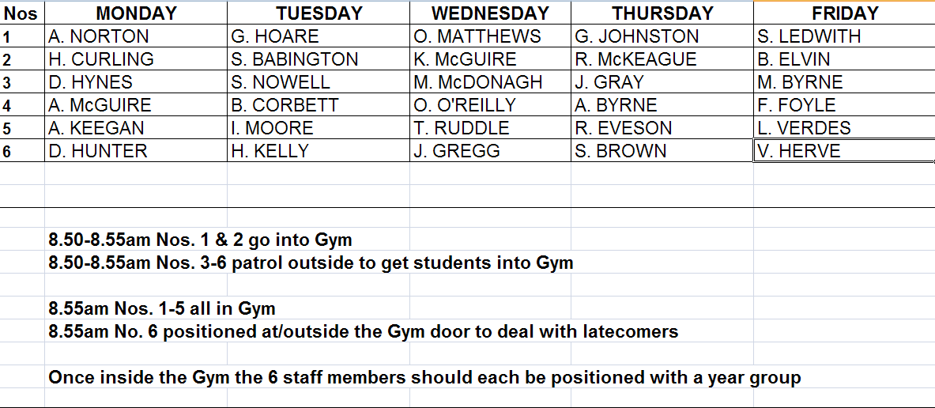

Dundalk Grammar School Limited
The Directors of Dundalk Grammar School Limited have put in place a Communications Policy as follows: -
Email, Internet and Telephone Usage
Under law the company can be held liable if employees use company email, Internet access and telephones (including fixed line and mobile) for illegal activity. This policy is put in place to protect the interests of both the company and its employees.
Objective
The purpose of this policy is to provide all employees with clear rules on the use of electronic mail (email), the Internet and the telephone, including texting, facsimile, landline and mobile phones at work. Email refers to Internet email, messaging systems, and any internal email system that may be in operation.
The email system, Internet access and telephones are for the use of employees for educational and business purposes to do with Dundalk Grammar School, Dundalk Grammar School Limited reserves the right to carry out certain monitoring functions to ensure compliance.
The aim of the policy is to ensure that:
- Dundalk Grammar School’s email system, Internet access and telephones are used only for Dundalk Grammar School’s educational use;
- costs are controlled;
- computer viruses are detected and eliminated;
- unsuitable material is not accessed or distributed;
- Dundalk Grammar School Limited meets their employer obligations under the laws of the Republic of Ireland.
Any breaches of this policy shall be subject to disciplinary procedures up to and including dismissal.
Policy
Email and Internet
The school email and Internet systems are to be used only by the employees of Dundalk Grammar School for educational and school business purposes.
Personal contacts should be asked not to send non-school related email to a Dundalk Grammar School email address.
Any Internet connection is to be used only for educational and business purposes to do with Dundalk Grammar School.
Exceptions can be made when it is used for employment related study and accessing work related sites and literature.
Certain material and site access is specifically prohibited to protect Dundalk Grammar School Limited and their employees.
DUNDALK GRAMMAR SCHOOL
Examples of email or Internet content which is unsuitable and therefore shall not be accessed or distributed include:
- jokes and games
- racist or discriminatory material
- offensive or sexually explicit material
- threatening, harassing or obscene messages
- chain messages
- web-sites _containing pornography
- any unauthorised information or unlicensed software

All email is the property of Dundalk Grammar School Limited and the Directors reserve the right to review the content of email and Internet usage.
The Internet and email shall not be used by employees for personal gain or profit or to pass themselves off as someone else.
Use of the Internet or email to support unauthorised or illegal activities, to provide lists or other information about employees to others, or to send classified / confidential information without approval is also forbidden.
Special care must be taken when sending approved confidential information and / or privileged information by email. When an email leaves the user’s computer it is less secure as it passes across public networks. All email communications should be treated the same as normal mail documents. Courts can treat email messages as documents which may be called in evidence by way of a court discovery order.
The Internet or Email must not be used to infringe the privacy rights of any person and / or the intellectual property rights or copyrights of third parties. Employees must not use the Internet or Email to convey defamatory, fraudulent or harassing messages, or otherwise engage in any illegal or wrongful conduct.
Dundalk Grammar School Limited maintains virus protection software. However, care must be taken when sending or receiving attachments or downloading Internet content.
Moderate and temperate language shall be used at all times.
Telephone
Dundalk Grammar School Limited acknowledges that employees may need to use the company telephones or company mobile phones for emergency personal calls.
The telephone must not be used to infringe the privacy rights of any person and / or the intellectual property rights and copyright of third parties. Employees must not use the telephone to convey defamatory, fraudulent or harassing messages, or otherwise engage in any illegal or wrongful conduct.

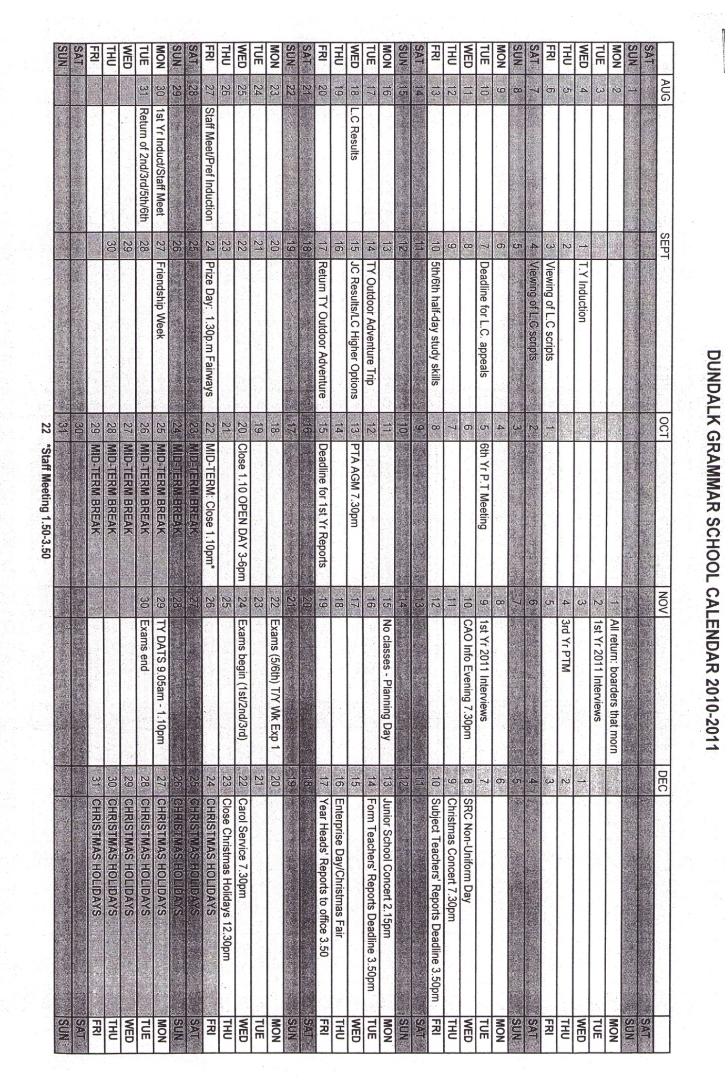

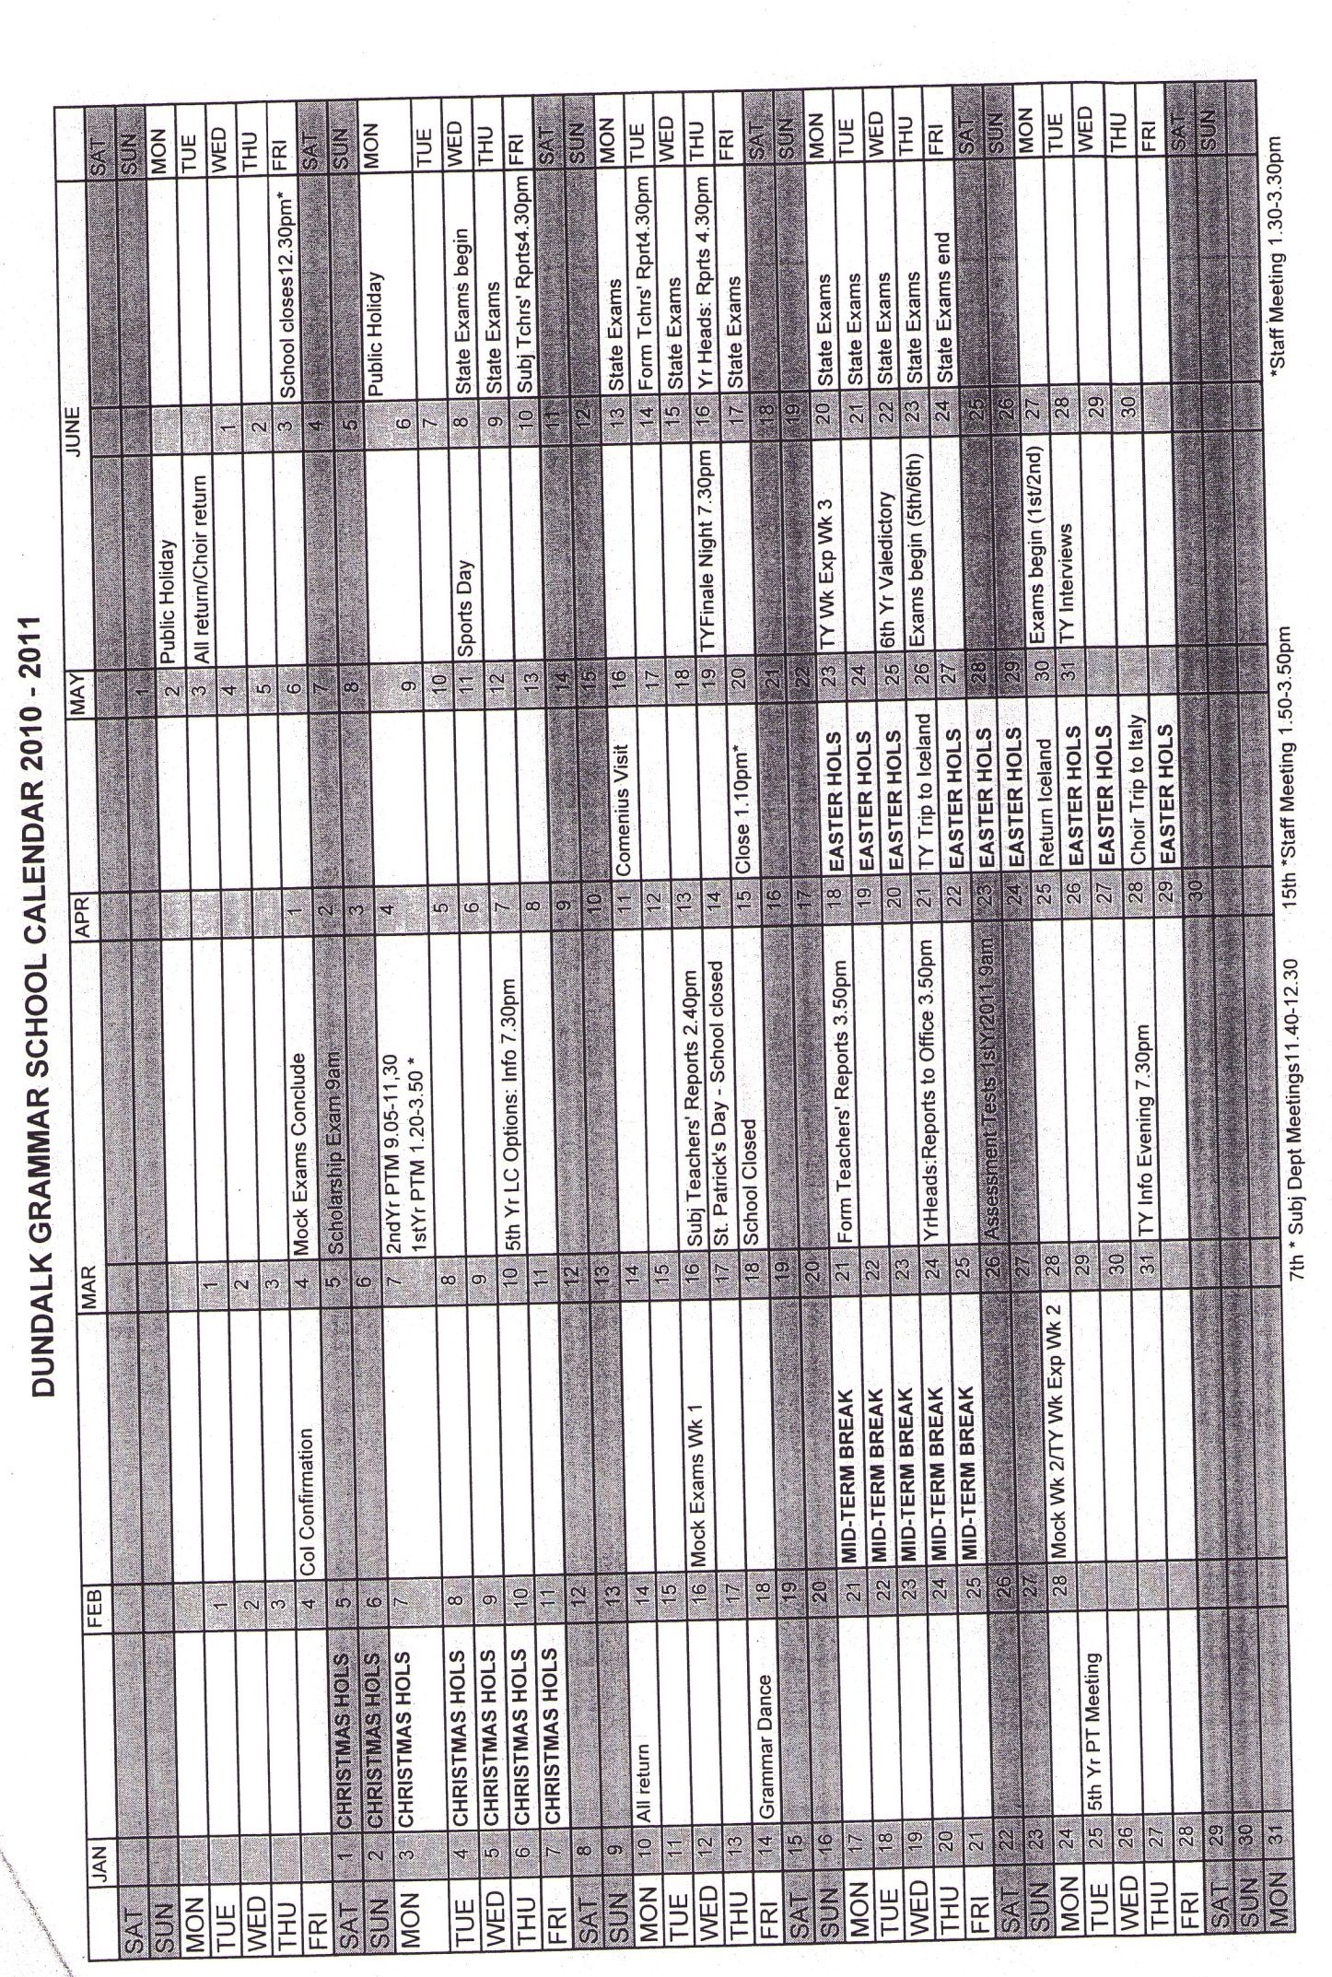

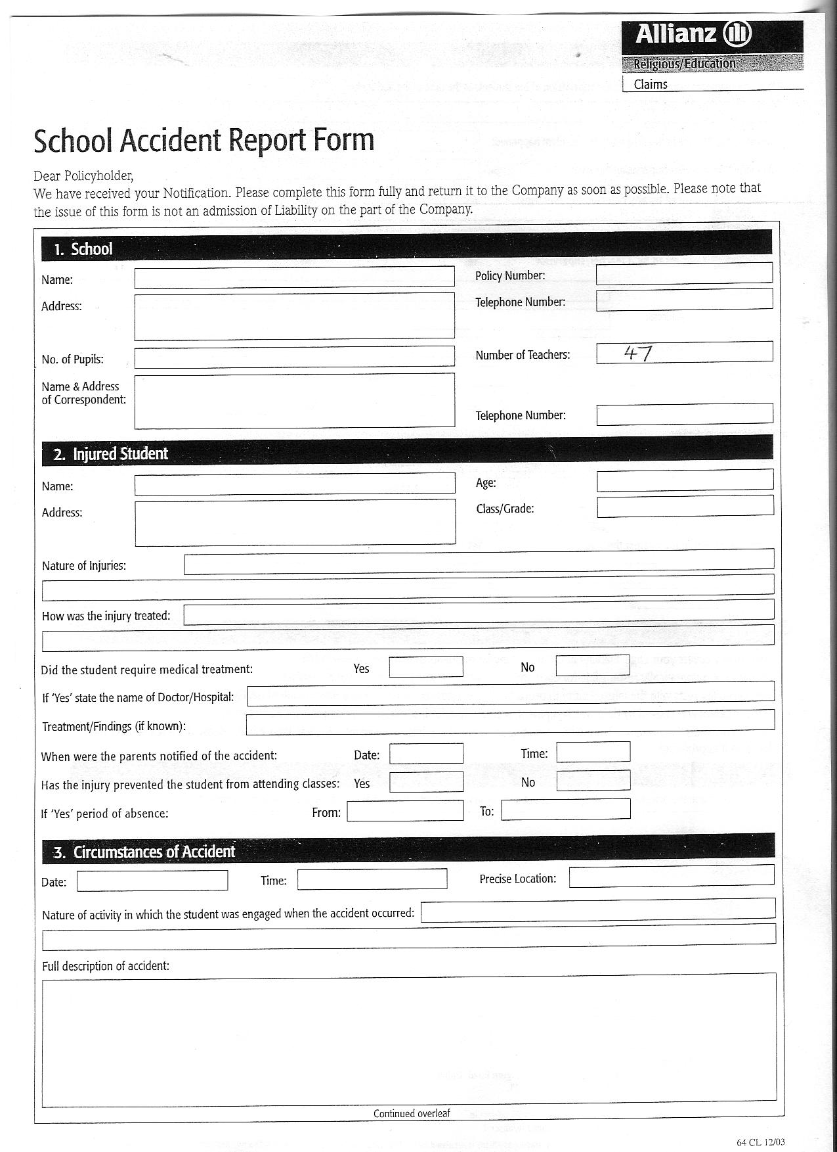

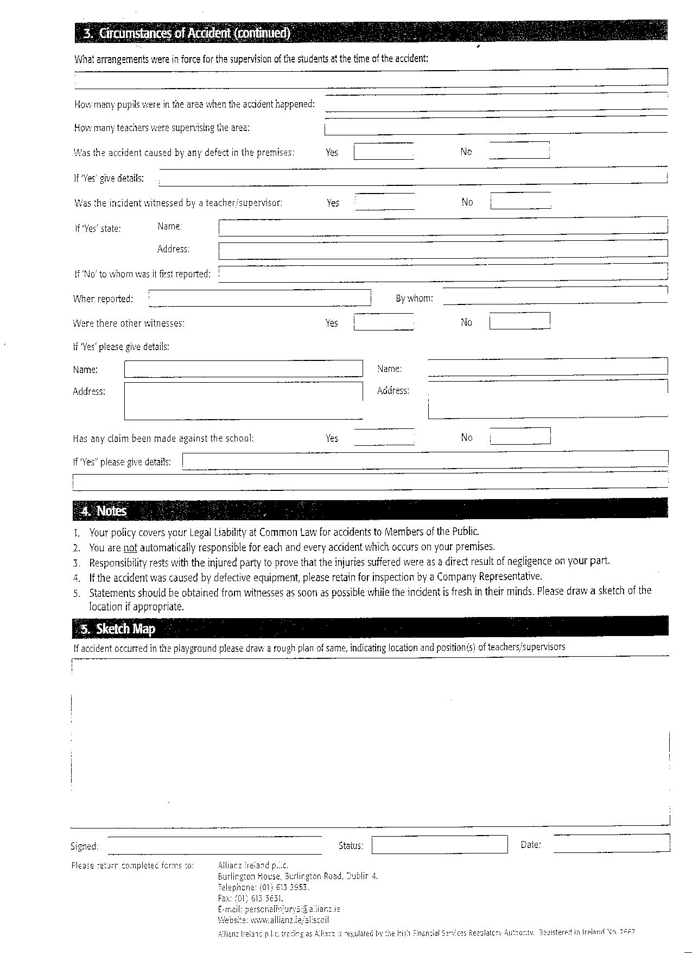

Bullying Record Form

Date___________________________Time________________________
Teacher________________________Class________________________

Names of those involved _______________________________ _________ __
_ _________ _________________________________________ ____ _______
_ __ ________________________________________________________

Details of Incident _______________________________ _________ __
_ _________ _________________________________________ ____ _______
_ __ ________________________________________________________

Action taken (Warning, Agreement, Mediation, Sanctions, Referral, Other)
________________________________________________________________
________________________________________________________________
________________________________________________________________
Signed Pupil ___ ___________________________ _
Teacher ______ ________________________ _
Parent _________ _____________________ _
Suggestions for follow up ______________________________ _
_________ ___ _________ ________________________________________
____ ________ _____________________________________ ___________

School Trip Consent Form
Please complete and return the attached permission slip to the Form Teacher.
Title of Trip …
Date of Trip
Teachers/Classes ………………………………………………………………………………………………………………………..
Destination ………………………………………………………………………………………………………………………………..
Details…………………………………………………………………………………………………………………………………………
……………………………………….
…………………………………………………………………………………………………………………………………………………….

------------------------------------------------Detach Here------------------------------------------------------
School Trip: ………………………………………………………………………………………………………
Medical Considerations: Are you aware of any injury/illness or allergy that may affect your child’s participation in this trip? Yes/No ………. If yes, please explain giving any relevant treatment/care information and provide any medication for use on the day
Complete using BLOCK CAPITALS please.
Pupil’s name: ……….
Address:
Telephone number/ mobile number:
I give permission for the above named student to participate
Signed…………………………………….. (Parent/Guardian)

I do not wish for the above named student to participate for the following reason:

Signed…………………………………….. (Parent/Guardian)

Date………………………………………..
In the absence of written permission students may not be allowed to participate in this trip

FIRE ALARM: INSTRUCTIONS TO STAFF

IN THE EVENT OF DISCOVERING A FIRE
- Make a decision as to whether the fire can be quickly contained by using a fire extinguisher, e.g. in the laboratory.
- If not, Evacuate the Building in accordance with the procedure below.
- Activate the fire alarm by breaking a Break Glass Fire point. (These are situated near most exit points).
- If possible alert the Headmaster (or Vice-Principal).

EVACUATION OF THE BUILDING
- The main responsibility of staff is to guide pupils to safety to ensure a swift and orderly evacuation of the building.
During supervised class periods:-
The class should be told to
- Leave all books, bags, etc
- Rise from their seats
- At the direction of the teacher to file out in an orderly fashion – walking not running.
Having ascertained that the room is empty and this includes any adjacent stores, the teacher should leave, closing the door behind him or her.
- At other times:
The teacher should assume responsibility for the area that they are in – ensure that all pupils leave the building as quickly as possible and are directed to an assembly point. Members of staff should endeavour to check pupil access areas to ensure that they are clear before leaving the building.
Outdoors
Assembly will take place on the Astro-Turf pitch opposite their class sign.
- Students will meet their form teacher here, and
- Line up in an orderly straight line opposite their class sign on the Astro-Turf fence.

- All T classes and ‘R’ classes (The Verandah) are to enter the Astro-Turf pitch by means of the avenue.
- Science labs Art room, Library and H.E. room students should use the fire escapes and cross the all weather pitch to the Astro-Turf entrances.
- All classes to take the shortest, safest route to the Astro-Turf pitch. Please use both gate entrances to the pitch (one near goal posts).
- Form Teachers (or Substitute Teachers) will be given a form class list to be checked carefully. Absentee students to be noted and checked against roll list.
- Form Teachers to remain with pupils until fire drill is over.
- Students should then return to class/break/lunch in an orderly manner.

UNIFORM COMMUNICATION SYSTEM
All breaches of the Uniform Guidelines and other instances of inappropriate appearance should be recorded on the uniform spreadsheet on the staff room notice board.
Sanction | Communication | Actions:
1: Verbal Warning | Noted on uniform spreadsheet on staff room notice board | Staff member enters the student’s name, ticks the appropriate box(es) and dates and, initials the entry. These entries will be transferred to the file by Ms. Byrne.
2: Letter to parent | Letter for parent handed to student (receipt to be acknowledged to Ms Byrne) | Following on from a second record in the uniform file, Ms Byrne records student name and class on template letter and places in envelope marked Private & Confidential FAO Parent/Guardian". This letter may be given to Form teacher or handed directly to student.
3: Detention (Friday) | Letter to parent posted by office | following a third record in the staff room.  uniform book, Ms Byrne records student name and class and date of detention on template letter. If office receive on Friday 4pm, they will insert address on letter, copy to (i) student file and (ii) Year Head, and lace in no later than Tuesday 4 pm.

Notes:
Year Heads will follow up missed detentions and these will be dealt with through the standard school disciplinary procedures.
In line with normal school policy, any member of staff may additionally contact a parent by telephone in relation to concerns about uniform or appearance e.g. a parent may be contacted by telephone to inform them that a student has received a verbal warning about uniform/appearance.
If a uniform/appearance infringement is considered to be sufficiently serious then it should be referred immediately for consideration by the Year Head (for detention) or the Deputy Principal/Headmaster for suspension).
Headmaster
August 2010.

PROCEDURES RE UNIFORM AND APPEARANCE
In accordance with school regulations students must at all times be dressed correctly. School uniform should be correct, clean and in good repair and worn neatly. Jewellery is forbidden apart from one stud earring in each ear for girls; make-up and nail polish are not allowed. Please refer to both Uniform Guidelines and the Code of Behaviour. All staff are asked to assist in ensuring high standards of school uniform.
JEWELLERY
All jewellery (except a pair of ear studs for girls) should be confiscated and placed in a plastic bag from a supply kept under the phone in the staffroom. Students’ particulars should be written on the front of the bag and given to Ms. Martina Byrne who will keep it until the confiscated jewellery is returned to the student concerned.
MAKE-UP
Students wearing make-up should be asked to report to Ms. Byrne who will reprimand and direct removal of the make-up/ nail varnish. A box of wipes, nail varnish remover, etc. will be kept under the phone in the staffroom and in the school office.
HAIR
Students with unacceptable hairstyles and / or colouring should be reprimanded and given a date by which the necessary changes should be made. (An extreme case will mean immediate suspension.)
UNIFORM AND APPEARANCE
A "Uniform Spreadsheet" will be placed on the staffroom notice board.
Should any member of staff have reason to reprimand any student over uniform or appearance, the staff member should enter the student’s name on the spreadsheet, tick the appropriate box(es), date and initial the entry.
If a second tick is entered, Ms. Byrne (and / or Form Teacher) will contact parents by phone / letter.
A third tick will ensure a Friday detention, and a letter notifying detention will be sent home.
The school reserves the right to remove from class, or suspend, any student whose dress or appearance does not conform to the school’s uniform code.

Child Protection Guidelines
For Post-Primary Schools
"Children First", the national child protection guidelines published in September 1999, noted that school staff are particularly well placed to observe and monitor children for signs of abuse. It called on schools to put in place clear procedures which school staff must follow where they suspect, or are alerted to possible child abuse.
The "Child Protection Guidelines for Post-Primary Schools", was produced to meet this need. The Guidelines reflect the particular circumstances of the post-primary school setting and provide management authorities and school staff with guidance in relation to recognising the signs and symptoms of child abuse and with procedures for dealing immediately with such concerns. The Guidelines should be taken in conjunction with Children First and not as a stand-alone document
A central facet of the Guidelines is the requirement for each Board of Management to designate a senior member of staff as the Designated Liaison Person (DLP) for the school. The DLP will act as a liaison with outside agencies such as health boards and as a resource person to any staff member who has child protection concerns.

Recognising child abuse.
Child abuse can take different forms, but usually consists of one or more of the following:
Neglect: Where a child’s needs for food, warmth, shelter, nurturance and safety are not provided to the extent that the child suffers significant harm.
Emotional Abuse: Where a child’s need for affection, approval, consistency and security is not being met.
Physical Abuse: Where a child is assaulted or injured in some way that is deliberate.
Sexual Abuse: Where a child is used for the sexual gratification of another.
The Guidelines provide advice on the signs and behaviours that may be indicative of child abuse.

What responsibilities have school personnel?
Schools have an obligation to provide students with the highest possible standard of care in order to promote their well being and protect them from harm. School personnel are especially well placed to observe changes in behaviour, failure to develop or outward signs of abuse in children. In situations where school personnel suspect that a child may have been abused, or is being abused, or is at risk of abuse, they should ensure that such concerns are reported in accordance with the procedures outlined in the Guidelines.

Reporting concerns to the Health Board:
If a member of staff receives an allegation or has a suspicion that a child may have been abused, or is being abused, or is at risk of abuse he/she should, without delay, report the matter to the school DLP.
If the DLP is satisfied that there are reasonable grounds for the suspicion or allegation he/she should report the matter to the relevant health board immediately.
If the DLP is not sure whether to report the matter to the health board, the DLP should seek advice from the Duty Social Worker in the health board.
If the DLP decides that the concerns of a member of staff should not be reported to the health board, the member of staff should be given a clear statement, in writing, as to the reasons why. The member of staff should be advised that, if he/she remains concerned about the situation, he/she is free to consult with or report to the health board.

What will the Health Board do with a report?
Once a report of suspected child abuse has been made to a health board, it is then a matter for that health board to decide upon the action, if any, which is necessitated by that report. The social worker handling the case may need to seek further clarification from the person who first raised the concerns. In some cases, the response of the health board will be to call a child protection conference.
Allegations or suspicions of child abuse concerning school employees:
In a school context, the most important consideration to be taken into account is the protection of children, and their safety and well being must be the priority. However, the school also has duties and responsibilities, as an employer, in respect of its employees.
School employees may be subject to erroneous or malicious allegations. Therefore any allegation of abuse should be dealt with sensitively and support provided for staff including counselling where necessary. The employee should be treated fairly which includes the right not to be judged in advance of a full and fair enquiry.
It is important to note that there are two procedures to be followed:
- the reporting procedure in respect of the allegation;
- the procedure for dealing with the identity employee.
In the case of post-primary schools, the DLP is responsible for reporting the matter to the appropriate health board while the Employer is responsible for addressing the employment issues.
Protocol authorising immediate action.
The Guidelines provide a written protocol by which the Employer may authorise the school Principal to absent an employee from the school where circumstances warrant it as a precautionary measure in order to protect children in the school.
Where the Protocol authorizing immediate action is invoked to absent an employee from the school an emergency meeting of the Employer body should be convened.
Action to be taken by the employer.
The Guidelines provide advice to the Employer on the immediate actions to be taken where a report has been made to a health board concerning a school employee.
It is essential that at all times the matter be treated in the strictest confidence and that the identity of the employee should not be disclosed until such time as the employee has been offered the opportunity to address and/or be represented to the employer.
Further follow-up required.
The Guidelines advise that the employer should maintain strict confidentiality and that any further follow-up action should accord with the established grievance and disciplinary procedures for the sector.
Feedback from Health Boards.
The Children First guidelines place an onus on health boards to ensure that arrangements are put in place to provide feedback to employers in regard to the progress of a child abuse investigation regarding an employee. It is clearly stated in those guidelines that efforts should be made to investigate complaints against employees promptly bearing in mind the serious implications for an innocent employee.
Peer abuse and bullying
The Guidelines provide advice on the recognition and reporting of abuse perpetrated by a child’s peers. It is important that potentially abusive behaviour between children is not ignored and, as appropriate, certain cases should be referred to the health board.
School management is responsible, in the first instance, for dealing with bullying in school. The more extreme forms of bullying behaviour, when perpetrated by adults rather than children, would be regarded as physical or emotional abuse. Only such serious incidences of bullying should be referred to the health board.
Forms and contact details.
The Guidelines provide a Standard Reporting Form and contact details for the relevant Health Board as well as Guidance Notes on Child Protection Conferences.
The Guidelines are available on the Department of Education & Science web-site at http://www.education.ie

DUNDALK GRAMMAR SCHOOL
DIGNITY AT WORK CHARTER
A core employment value is the commitment to ensuring that each individual is guaranteed a working environment where s/he may expect to be treated with dignity both by management and colleagues.
This approach is a positive demonstration of the importance of each individual and the contribution s/he makes to the success of the workplace. It guarantees the optimal working conditions that allow individuals freely to maximise their role in the workforce. Sound management ethos is based on providing leadership that encourages individuals in this regard. This is best achieved in Dundalk Grammar School through the creation and maintenance of a positive working environment.
Integral to this employment value and in particular to the principle of mutual respect is the commitment to provide a workplace free from bullying. It is in such a context that the Dundalk Grammar School philosophy and policy statement is realised.
This policy applies to the behaviour of Dundalk Grammar School staff both in the workplace and at work-associated events, whether on or off the premises.
In addition to any penalty imposed by Dundalk Grammar School, those responsible for harassing others may be subject to criminal and/or civil proceedings. Nothing in this policy or its procedures can prevent members of staff from exercising their legal rights.
DIGNITY AT WORK CHARTER: OBJECTIVES AND POLICY
The purpose of this document is to outline the Board’s policy and procedures in relation to workplace bullying.
The objectives of the Board’s policy are:
- to support the general aims of the Dignity at Work Charter
- to contribute to a supportive environment where staff members have the right to carry out the work of the school - ‘the education of the whole person’
- to eliminate workplace bullying
A complaint of workplace bullying may, following due procedure, result in disciplinary action up to and including dismissal.
In approving this policy document, the Board has agreed that:
- it be brought to the attention of all staff
- all staff be asked to co-operate in its implementation
The policy guarantees that all complaints will be taken seriously and investigated promptly, and that all parties involved will be treated with respect and appropriate confidentiality will be maintained,
Staff will be protected from victimisation or from discrimination for assisting in an investigation. Victimisation arising as a result of a member of staff raising a complaint will not be tolerated. Any such victimisation or discrimination will be treated as bullying and will be subject to disciplinary action.
DEFINITIONS
Bullying
Workplace bullying is repeated inappropriate behaviour, direct or indirect, whether verbal, physical or otherwise, conducted by one or more persons against another or others, at the place of work and/or in the course of employment, which could reasonably be regarded as undermining the individual’s right to dignity at work. An isolated incident of the behaviour described in this definition may be an affront to dignity at work, however, a once-off incident is not considered to be bullying.
(Codes of Practice 2002 under the Industrial Relations Act and the Health and Safety at Work Act 1989)
Harassment and Sexual Harassment
The Employment Equality Acts, 1998 and 2004 specifically deal with harassment in the workplace. The new code aims to give practical guidance and advice. Harassment that is based on the following nine grounds - gender, age, marital status, family status, sexual orientation, disability, race, religion or membership of the travelling community - is a form of discrimination in relation to conditions of employment.
Sexual Harassment
Sexual harassment is defined in the Equality Act 2004 as any form of verbal, non-verbal or physical conduct of a sexual nature which has the purpose or effect of violating a person’s dignity and creating an intimidating, hostile, degrading, humiliating or offensive environment for the person. The unwanted conduct may consist of acts, requests, spoken words, gestures or the production, display, or circulation of written words, pictures or other material. (Employment Equality Act 2004)
Harassment
Harassment on the other eight grounds covered by the legislation is any unwanted conduct related to any of the eight grounds (other than gender) where the conduct has the purpose or effect of violating a person’s dignity and creating an intimidating, hostile, degrading, humiliating or offensive environment for the person. The unwanted conduct may consist of acts, requests, spoken words, gestures or the production, display or circulation of written words, pictures or other material. (Employment Equality Act 2004)
Unacceptable Behaviour and Workplace Bullying
Under the Health and Safety at Work Act 1989 there is a requirement that personnel be consulted in respect of acceptable/unacceptable behaviour and that through this consultation process, the staff will have ownership of the policy as it relates to their school. The following are headings and the list is not intended to be exhaustive.
- Aggressive behaviour/attitude/body language
- Intimidation; physical, psychological or emotional
- Public or private humiliation
- Ostracism and/ or marginalisation
- Insidious, less obvious forms of subtle and manipulative behaviour, which undermines the dignity and self-respect of the victim.
NOTE
Legitimate, constructive and fair criticism by management of a staff member’s performance or behaviour at work will not be considered to be bullying or harassment. Poor work performance will be dealt with through the operation of fair procedures and not through an aggressive management style. Bullying will not be condoned under the guise of ‘strong management’. An assertive management style is acceptable provided that staff members are treated politely and with respect.
Legitimate management responses to exceptional situations, which require immediate action or which arise from staff shortages and consequent increased workload, do not constitute bullying.
EFFECTS OF BULLYTNG
Research shows that the effects may be physiological, psychological and behavioural. There are consequences for the individuals who perceive themselves to be targets of bullying behaviour, for the alleged perpetrator(s), for the organisational culture and the ethos of the school, and for the Board of Governors.
Effects on the Individual
There will/may be
- loss of self-confidence
- increased risk of suffering stress with consequent adverse effects on health and on career
Effects on the Organisation
There may be
- under-performance/ achievement by those bullied
- increased sickness/absenteeism
- low morale
- a tense atmosphere, not conducive to good working relations
- the formation of cliques or factions
FACTORS INHIBITING DISCLOSURE OF A BULLYTNG INCIDENT
(l) The particular workplace culture may passively support bullying because staff in general are unaware of the seriousness of bullying.
(2) Lack of witnesses to back up the complaint.
(3) Fear
- that the complaint may not be taken seriously
- of being perceived as unable for the job, and/or a weak person, as lacking credibility, and/or other personal status
- of reprisals or of further intimidation
- that senior management will support an allegedly bullying colleague/manager/supervisor ·
STEPS TO PREVENT BULLYING IN THE WORKPLACE
- familiarity with the school’s policy and how it works
- having a sense of personal responsibility for the school’s policy
PROCEDURE FOR DEALING WITH BULLYING IN THE WORKPLACE
Employees should be advised that, if possible, they should attempt to resolve the problem informally in the first instance.
Stage One is an informal process and Stage Two is a formal process.
STAGE ONE Informal resolution
Where possible, the informal process is to be preferred. The designated contact person(s) (see below) can advise on both stages. If, having decided to follow Stage One, the problem persists, the complaint can then be dealt with under Stage Two. Complainants are under no obligation to pursue Stage l first, but may begin with Stage 2. No aspect of this policy affects any employee’s individual legal rights to take their complaint outside of the school.
The complainant should:
- clearly identify the problem
- tell the bully that his/her behaviour has to stop. It may be possible and sufficient for the employee concerned to explain clearly to the person engaging in the unwanted conduct that the behaviour in question is not welcome, that it offends him/her or makes him/her uncomfortable and that it interferes with his/her work. (This may be more difficult for some individuals than for others.)
- if it is impossible to confront the bully, tell somebody - initially this should be a contact person, the headmaster, the deputy principal, and/or another colleague. Contact persons shall have received training in the procedures. The headmaster, as the school’s chief operating officer, must be advised if the probability of a speedy resolution appears unlikely.
- it is of the utmost importance to GET HELP AND SUPPORT.
- keep notes, detailing times and dates of incidents of bullying/harassment and request eyewitnesses, if any, to note them also.
STAGE TWO: Formal procedure
a) A written report should be made, signed by the complainant and given to the headmaster.
b) Prior to the commencement of Stage Two of the investigation the alleged perpetrator will be given a copy of the formal written complaint and advised that an investigation will commence in not less than three school days and not more than fourteen school days from receipt of the written complaint. A finding in favour of the complainant may lead to disciplinary action being taken against the perpetrator.
c) Both the complainant and the alleged perpetrator will be advised of their right to be accompanied and/or represented by their union representative or a colleague at all meetings and these shall be recorded.
d) Two individuals suggested by the Board of Governors and accepted by the complainant and the alleged perpetrator will investigate the complaint with minimum delay and as confidentially as possible. One of the investigators shall be the same sex as the complainant if so requested. Due respect shall be had for the rights of the complainant and the alleged perpetrator.
e) Where a complaint is found to be substantiated in a written report from the two investigators, the extent and nature of the bullying/harassment will determine the form of the disciplinary action to be taken. These actions may include a verbal warning, a written warning, suspension from duties with or without pay, suspension from full duties with or without pay or dismissal.
Ultimate disciplinary action is the responsibility of the Board of Governors.
f) Where an employee is victimised as a result of invoking or participating in any aspect of the complaints procedure, including acting as a witness for another employee, such behaviour will also be subject to disciplinary action.
No record of any complaint will be registered on an employee’s file unless the formal procedure (Stage Two) outlined above has been invoked.
It is the opinion of the school that issues of bullying/harassment are best dealt with within the school.
Where any staff member does not find it appropriate to report to the headmaster as above, he/she may report to the deputy principal, chairperson of the Board of Management, or the chairperson of the Board of Governors. The list of personnel available as contact persons should reflect gender balance.
If it is found that the perpetrator’s behaviour had been misinterpreted and s/he was genuinely unaware of the effect of his/her actions, further procedures may not be necessary as the investigation may come to an end. Recurring problems would be subject to further investigation.
PERFORMANCE CRITERIA WITH WHICH TO JUDGE THE EFFICACY OF THE POLICY
- The existence of a policy based on the ‘Dignity in the Workplace Charter’ and the prevention of workplace bullying as part of health, safety and welfare at work
- Awareness/availability of policy
- Dignity in the Workplace as well as inappropriate/bullying behaviour are defined in the school’s policy
- An employee’s right to complain is respected
- Informal resolution of complaints is encouraged
This document is a requirement under Health and Safety legislation, Section 6 and future Codes of Practice as may be introduced under the Health and Safety legislation, Employment Equality Act, and Industrial Relations Act. The policy is subject to periodic review.

Board of Governors,
Dundalk Grammar School

Dear Staff Member,
The purpose of this document is to ensure that the Board of Governors of Dundalk Grammar School is compliant with current legislation in relation to the Health and Safety Requirements under Section 6(i) of the 1989 Act as follows:
It shall be the duty of every employer to ensure, so far as is reasonably practicable the safety, health and welfare at work of all his employees.
A copy of this document will be issued to each staff member of Dundalk Grammar School. It is each employee’s responsibility to ensure that s/he becomes familiar with the contents of this document.
A copy of the Dignity at Work Charter will be displayed on the school premises in order that management, staff, visitors and time general public may view it.
In the event of a complaint in relation to bullying in the workplace in Dundalk Grammar School, the procedures contained within will be followed.
This document will be subject to periodic review.
Robert A. Smyth
USEFUL CONTACTS.
The Health and Safety Authority
Address: 10, Hogan Place, Dublin 2.
Tel: 01 614 7000 Fax: 01 614 7020 Website: www.hsa.ie

Labour Relations Commission,
Tel: 01 613 6700 Fax: 01 613 7601 Website: www.lrc.ie

Department of Enterprise, Trade and Employment
Tel: 0l 613 3131 Fax: 01 631 3267 Website: www.entemp.ie

Equality Authority
Tel: 0l 417 3333 Fax; 01 417 3366 Website: www.equality.ie

See also:
- Report of the Task Force on Prevention of Workplace Bullying
- HSA Code of Practice on Workplace Bullying
- LRC Code of Practice on detailing procedures for addressing bullying in the workplace
- Equality Authority Code of Practice on Harassment and Sexual Harassment

Students’ Lockers 2010-2011

BOARDERS
Girls (Junior & Senior) | Bell Corridor
Boys (Junior & Senior) | Beside outer door of day canteen

DAY STUDENTS
Form 1 (Girls) | Outside R8 to the left of the steps
Form 1 (Boys) | Black & white tiles at the foot of the stairs to R8; a small number as for Form 1 girls
Form 2 (Girls) | Prefabs (hallways)
Form 2 (Boys) | Verandah
Form 3 (Girls) | Black & white tiles beside canteen serving area
Form 3 (Boys) | Verandah
Form 4 (Girls) | Outside R8 to the right of the steps
Form 4 (Boys) | Former tuck shop (4B, 4G, 4R), R5 (4W)
Form 5 (Girls & Boys) | New Building, ground floor
Form 5 (Girls & Boys) | New Building, first floor

Students must not enter any locker area apart from their own, except en route to class (e.g. Verandah; route to R8, New Building first floor).

GUIDELINES FOR PROBATIONARY TEACHERS

DUNDALK GRAMMAR SCHOOL
CODE OF PROFESSIONAL CONDUCT
As registered members with the Teaching Council all staff should be familiar with and adhere to the Teaching Council’s Code of Professional Conduct for Teachers

It is impossible to lay down guidelines to cover every situation and circumstance. As with all things in education it is prudent for everyone to review how they interact with the students, whether that is their teaching style or their approach to the young people in their care, so that their intentions can never give rise to grounds for concern or doubt. At all times professional judgement must be exercised and it is expected that these guidelines will reassure the vast majority of staff that what they have been doing in the course of the exercise of their duties has been in keeping with best practice.
Teachers are in a position of trust and their behaviour when interacting with students must be above reproach at all times. Any action by them in relation to students must always be in the best interests of the young person. The position of trust places the teacher "in loco parentis" which means that the teacher should exercise the duty of care that a careful and responsible parent would exercise in similar circumstances. Any staff/volunteer relationship with a student which breaches the boundaries of professionalism and respect is unethical and unacceptable. That boundary between the adult and the child cannot be breached in any circumstances.
While it is appropriate to encourage and foster a warm friendly relationship with students, staff must always maintain an arms-length professional relationship.
As a guiding principle, any physical contact which is likely to be misinterpreted by the student, parent or another person should be avoided. School personnel must always remember who is the adult, and on him/her rests the primary responsibility to ensure that a proper, professional relationship is maintained with each student.
There are occasions when confidential meetings or one-to-one teaching must take place. As far as possible, staff should conduct such meetings in a room with visual access or with the door ajar. A similarly circumspect approach should be adopted in extra-curricular related activities involving small numbers.
It is recommended that first aid should be administered in the presence of other students or another adult. However, no member of the staff should hesitate to provide first aid in an emergency even if another person is not present.
The school environment should be one where everyone, staff and students treat each other with respect and dignity, free from harassment, intimidation or offensive behaviour in any form, verbal or non verbal.
Harassment is defined as unwanted conduct that is offensive to the recipient. In what is becoming a more multi-cultural society, management, staff and students must ensure that the school environment is free from harassment or discrimination of any type. Offensive language, sexual comments, offensive jokes, racist remarks, offensive text messages, offensive e-mails, offensive or pornographic web sites are among the areas that are unacceptable.
Any phone contact with students, particularly outside school hours, should be avoided, unless it is absolutely necessary and for a stated school purpose.
A student may be asked to empty his/her pockets or the contents of his/her bag where there is a reasonable belief that the student is in possession of stolen goods, illegal substances or weapons. If a student refuses s/he may be asked to accompany the member of staff to the DP’s/HM’s office.
Experience would suggest that the prompt action of a teacher or teachers moving towards an incident often results in bringing a potentially dangerous situation between students to an end. A shout or call to order is often all that is needed but there may be a need for physical intervention and the use of "reasonable force" to prevent injury. Not to intervene when there is a possibility of injury to a person or damage to property would be a failure in one’s duty of care to all students. Reasonable force could include;
- physically interposing between pupils
- blocking a pupil’s path
- holding
- pushing or pulling
- leading a pupil by a hand or an arm
- shepherding a pupil away by placing a hand in the centre of a back, or in extreme circumstances, using more restrictive holds.
Sometimes, in a confrontational situation, the risk of assault by a student can arise for an individual member of the staff. While these situations are always difficult it is advisable in certain circumstances to stand back or walk away from a student, particularly where, by so doing, a potential confrontation with an emotionally charged student can be avoided or postponed to a calmer occasion. Particular examples of such circumstances might be where the student is beginning to lose his/her temper or is seeking to engage in a physical confrontation. Serious incidents of this nature must always be reported to the Headmaster/Deputy Principal.
Punctuality
Good timekeeping is an essential element of best practice in any profession. Teachers are asked to be punctual for class, form class, assemblies, duties and other school events. Likewise, students should never be released from class or from the Study Hall before the bell has rung signalling the end of class as this creates a situation in which students cannot be supervised.
First year students should be released from class and Study Hall at 1.00 p.rn. to allow them first access to the canteen. The teachers concerned should ensure that there is adequate supervision in place (at least one teacher on canteen duty and another outdoors) between 1.00-1.10p.m. An informal arrangement between the teachers concerned is sufficient, although there must be clarity as to who is in charge. Students may not be sent to the Study Hall without the permission of the Headmaster, Deputy Principal or Year Head.
Staff may not withdraw students from class without the permission of the Headmaster/Deputy Principal.
Attendance/Completion of Duties
Staff must familiarise themselves with the requirements and timetables for duties and be in attendance at the appropriate location throughout the duty period.
Dress
It is expected that all members of staff reflect their professional status in terms of dress and presentation while engaged in their duties. The wearing of overly casual clothing is not in keeping with the position and, as in other such work situations, formal work attire is preferable at all times. Where practicable (i.e. apart from practical subject areas) the School Management requires the wearing of the academic gown.
Curriculum & Classroom Management
It is important that teachers be familiar with the specific requirements of the school and the relevant subject department(s) with regard to schemes of work for each term; including the expected pace of each class based on level (Higher/Ordinary), homework policy, equipment and resources required for teachers and pupils, the advised frequency of class tests and arrangements for house exams.
Regular consultation with teaching colleagues will ensure that similar standards are maintained with regard to all of the above and that all comparable classes progress at the same rate.

DUNDALK GRAMMAR SCHOOL
GUIDELINES FOR BEST TEACHING PRACTICE
Introduction
1. It is important for a teacher to create an atmosphere that is conducive to learning.
Factors that help create this atmosphere include:
- the teachers personality
- enthusiasm
- appearance
- a positive attitude towards all pupils.
Courtesy, good manners and a kindly approach evoke a similar response on the part of the pupil.
2. The probationary teacher should first find out the content of the course to be covered and the exact requirements of the course and syllabus. (S)he should check this thoroughly if an examination class is involved. If taking over from another teacher (e.g. at 2"d year) (s)he should find out from the teacher of that class for the preceding year or from the Headmaster what exactly has been covered.
Section A: Preparation
1 Each lesson (or group of lessons) should be well prepared in advance. Unprepared lessons are often a minor cause of pupil indiscipline.
2. The preparation should cover;
- an accurate specific statement as to what the aim of the lesson is
- the content of the lesson
- the teaching methods to be used
- the activity of the pupils
- the kind of evaluation to be used
- a consideration of the natural divisions of the lessons.
3. Errors in preparation include;
- lack of specific aim
- material too difficult for the class
- trying to cover too much or too little in one lesson
- absence of variety in approach
- inaccurate and / or insufficient information in content and failure to be properly prepared for pupils ‘follow up questions’
- failure to foresee how the lesson will be presented.
4. Teaching methods should include a consideration of the type of aids to be used, the organisation of suitable examples, an array of suitable problems, questions and pupil activity.

Section B: Presentation of Lesson.
1. Presentation includes:
- pace of presentation
- kinds of illustrations, diagrams, aids, activities that will most effectively promote the aim of the lesson
- the division of the lesson into appropriate sections e.g. presentation of an aspect of the lesson by the teacher, pupil assimilation and activity, recapitulation, a further aspect of the lesson, evaluation teaching methods to be used.
2. The common errors in presentation are;
- covering too much too quickly
- teacher giving too much information, some of which the pupils already know. This knowledge should have been elicited previously by questioning
- focusing attention on one section of the class to the exclusion of the other sections
- lack of variety in approach e.g. all talk
- completely ignoring any attempt at evaluating the level of the pupils’ assimilation of the lesson; good presentation is constantly regulated as to pace and approach by the way the teacher structures feedback from pupils.
3. The following points may prove useful to remember during the course of the presentation;
- proceed from the experience of the pupils, from the known to the unknown, from the simple to the complex, from the concrete to the abstract
- as a point (or section or aspect) is treated, review it by asking pertinent questions or setting a written exercise. Towards the end of the lesson review the whole theme in similar fashion. This should be done by the pupils under the teacher’s guidance
- questioning should be specific and individual. Pupils should be obliged to put up their hands, and answer only when addressed directly by name. Choral answering should not be allowed. Address the question to the whole class and then select one to answer
- when addressing the class, wait for complete silence; never compete with the class for a hearing
- questions from the pupils should, in general, be encouraged but channelled towards the objectives of the lesson. Teachers should be quick to notice ‘red-herrings’
- use the standard aids available (e.g. blackboards, textbooks, tape recorder) and / or special aids prepared for the lesson (e. g. charts, diagrams).
- your voice is your most important aid: `
- speak distinctly and not too rapidly
- do not speak too loudly as you will tire yourself to no purpose
- as a professional person a teacher should realise that the quality of his / her speech both in and out of the classroom is under scrutiny
- time must be allotted to recapitulation at the end of a lesson This may be carried out orally but preferably by a combination or oral and other activity on the part of the pupils.
Section C: Evaluation ·
1. The commonest evaluation techniques are:
- questioning
- written exercises involving revision and application of new material
- oral discussion
- problem solving in either the arts or science areas
- creative work
2. Questioning
- do not include the answer in the question itself
- questions must be clear, concise, positive, exact
- questions should be directed to a particular pupil who should be named after the question
- questions should be asked once only
- one question at a time to avoid muddled thinking
- a badly constructed question should be cancelled
- economy of language in questions - short questions are most effective
- questions should provoke thought; generally avoid questions with ‘yes’ or ‘no' answers
- answers of pupils ought not to be repeated
- wrong answers should be corrected, but not in a discouraging way. If the answer is partially correct, help the pupil to amend it, if possible, but pupils ought not to be confused by a long series of subsidiary questions.
Student Discipline
(Please refer to document in staff handbook)

Break Lunchtime & Supervision Timetable

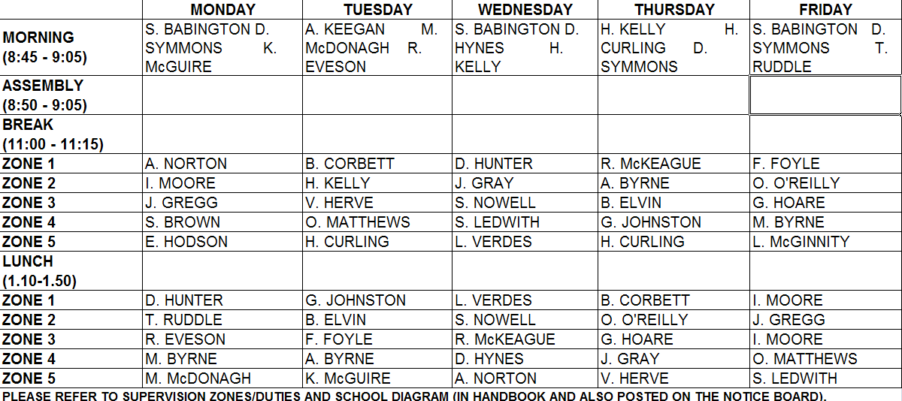

New Students 2010

Thongthip, Fern | 3G
Whyte, Gregory | 3R

Martin Cornejo, Jaime | 4B
Fitzpatrick, Fiona | 4G
MacGuinness, Robert | 4G
Martinez Mora, Carlos | 4G
McClelland, Gavin | 4G
Cullinane, Angel | 4R
McGee, Christopher | 4R

Dohmen, Felicitas | 5B
McDonnell, Declan | 5B
Esser, Lisa | 5G
McCormack, Declan | 5G
Whelan, Conor | 5G
Kinsella, Emma | 5R
Lang, Friederike | 5R

Students that have left 2010

Baldwin, Matthew | 2B
Lonergan, Peter | 2B
Eustace, Katie | 2W

Lonergan, Hannah | 3G

Collins, James | 4G
Crawford, Suzanna | 4G
O’Donoghue, Aidan | 4G
Rabbat, Sarah | 4G
Grills-Grant, Shane | 4W

Caneque, Mireia | 5B
Grennan, Olivia | 5B
Marin-Gallardo, Irene | 5G
Murphy, Bronagh | 5G
Darnaude-Ximenez, Ignacio | 5R
Froiz, Rodriguez, Andrea | 5W
Morris, Aine | 5W

Cueuas, Gil, Alejandro | 6G
Acebes-Garrido, Henar | 6W

1 Blue |  | 1 Green

1 Red |  | 1 White
2 Blue |  | 2 Green

2 Red |  | 2 White
3 Blue |  | 3 Green

3 Red |  | 3 White
4 Blue |  | 4 Green

4 Red |  | 4 White
5 Blue |  | 5 Green

5 Red |  | 5 White
6 Blue |  | 6 Green

6 Red |  | 6 White

